**Level 3 Creating an object oriented computer program using C# (7540-039)**

**Candidate Name: Camila Cardoso**

**Date: 18/09/2019 City & Guilds Enrolment number: CBX4920**

**Assignment A**

**Pre requisite**

* Have access to database hire.db;
* Have the SQLite;
* Have the Visual Studio;
* Have set up SQLite into Visual Studio:

System.Data.SQLite;

System.Data.SQLite.Core;

System.Data.SQLite.EF6;

System.Data.SQLite.Linq;

System.Data.SQLite.x64;

System.Data.SQLite.x86.

**Data Base Connection**



**System Functionality**

The system accesses the hire.db database using the tblCar table.

The fields of database are vehicle number should be unique, make is a string, engine size is a string field, date registered is a date and should have this format dd/MM/yyyy, rental per day is a numeric and available is an integer.

The user has access to data from the tblCar table, the first form allows user access to all existing records in the tblCar table.

The user can navigate through the Next, Last, Previous and First buttons.

The user can change the record if the data that the user would like to change is correct.

The user can insert records in the table if the data is valid.

The user is allowed to delete record.

The user may cancel the modification, inclusion or deletion of a record.

When the Search button is pressed the system opens the second FrmSearch form, the FrmCars form is locked.

User can access data from tblCar table through filters by Make, Engine Size, Rental Per Day and Available.

After the filter selected and the Run button is pressed all filtered records are shown on the screen.

**Test script**

|  |  |  |  |  |  |  |
| --- | --- | --- | --- | --- | --- | --- |
| **Test Case ID** | **Test Scenario** | **Test Steps** | **Test Data** | **Expected Results** | **Actual Results** | **Pass/Fail** |
| TC01 | Check the records on the form screen FrmCars | 1. Run the program | N/A | The first record of the tblCar table should be shown on the form screen FrmCars | As Expected | Pass |
| TC02 | Check the Next button | 1. Run the program  2. Click on Next button | N/A | The second record of the tblCar table should be shown on the form screen FrmCars | As Expected | Pass |
| TC03 | Check the Last button | 1. Run the program  2. Click on Last button | N/A | The last record of the tblCar table should be shown on the form screen FrmCars | As Expected | Pass |
| TC04 | Check the Previous button | 1. Run the program  2. Click on Previous button | N/A | The previous record of the tblCar table should be shown on the form screen FrmCars | As Expected | Pass |
| TC05 | Check the Fisrt button | 1. Run the program  2. Click on First button | N/A | The first record of the tblCar table should be shown on the form screen FrmCars | As Expected | Pass |
| TC06 | Check the Update button | 1. Run the program  2. Update the Make from the screen  3. Click on Update button | Put a valid value into Make field | The record should be Updated into the tblCar table | As Expected | Pass |
| TC07 | Check the Update button | 1. Run the program  2. Update the Engine Size from the screen  3. Click on Update button | Put a valid value into Engine Size field | The record should be Updated into the tblCar table | As Expected | Pass |
| TC08 | Check the Update button | 1. Run the program  2. Update the Date registered from the screen  3. Click on Update button | Put a valid date dd/MM/yyyy into Date registered field | The record should be Updated into the tblCar table | As Expected | Pass |
| TC09 | Check the Update button | 1. Run the program  2. Update the Rental Per Day from the screen  3. Click on Update button | Put a numeric value into Rental Per Day field | The record should be Updated into the tblCar table | As Expected | Pass |
| TC10 | Check the Update button | 1. Run the program  2. Update the Make from the screen  3. Click on Update button | Put spaces into Make field | The record should not be Updated into the tblCar table and an error message should appear on screen | As Expected | Pass |
| TC11 | Check the Update button | 1. Run the program  2. Update the Engine Size from the screen  3. Click on Update button | Put spaces into Engine Size field | The record should not be Updated into the tblCar table and an error message should appear on screen | As Expected | Pass |
| TC12 | Check the Update button | 1. Run the program  2. Update the Date registered from the screen  3. Click on Update button | Put invalid date into Date registered field | The record should not be Updated into the tblCar table and an error message should appear on screen | As Expected | Pass |
| TC13 | Check the Update button | 1. Run the program  2. Update the Rental Per Day from the screen  3. Click on Update button | Put a not numeric value into Rental Per Day field | The record should not be Updated into the tblCar table and an error message should appear on screen | As Expected | Pass |
| TC14 | Check the Add button | 1. Run the program  2. Click on Add button  3. Fill in all fields | Put a valid value for all fields | The record should be Inserted into the tblCar table | As Expected | Pass |
| TC15 | Check the Add button | 1. Run the program  2. Click on Add button  3. Fill in all fields | Put a value already exist in Vehicle Registration Number field | The record should not be Inserted into the tblCar table and an error message should appear on screen | As Expected | Pass |
| TC16 | Check the Add button | 1. Run the program  2. Click on Add button  3. Fill in all fields | Put spaces into Make field | The record should not be Inserted into the tblCar table and an error message should appear on screen | As Expected | Pass |
| TC17 | Check the Add button | 1. Run the program  2. Click on Add button  3. Fill in all fields | Put spaces into Engine Size field | The record should not be Inserted into the tblCar table and an error message should appear on screen | As Expected | Pass |
| TC18 | Check the Add button | 1. Run the program  2. Click on Add button  3. Fill in all fields | Put invalid date into Date registered field | The record should not be Inserted into the tblCar table and an error message should appear on screen | As Expected | Pass |
| TC19 | Check the Add button | 1. Run the program  2. Click on Add button  3. Fill in all fields | Put a not numeric value into Rental Per Day field | The record should not be Inserted into the tblCar table and an error message should appear on screen | As Expected | Pass |
| TC20 | Check the Cancel button into Add button | 1. Run the program  2. Click on Add button  3. Fill in all fields4. Click on Cancel button | Put a valid value for all fields | The record should not be Inserted into the tblCar table and the screen FrmCars should show all buttons and the first record from the tblCar table | As Expected | Pass |
| TC21 | Check the Delete button | 1. Run the program  2. Click on Next button until record 9  4. Click on Delete button  5. Click on Yes | N/A | The record 9 should be Deleted from the tblCar table | As Expected | Pass |
| TC22 | Check the Delete button | 1. Run the program  2. Click on Next button until record 2  4. Click on Delete button  5. Click on No | N/A | The record 2 should not be Deleted from the tblCar table | As Expected | Pass |
| TC23 | Check the Search button | 1. Run the program  2. Click on Search button | N/A | The FrmSearch should be shown on the form screen and the FrmCars should be blocked | As Expected | Pass |
| TC24 | Check the Search button | 1. Run the program  2. Click on Search button  3. Select Make into Field checkbox  4. Type H into Value textbox  5. Click on Run button | Checkbox Field = Make  Checkbox Operator blocked with the value =  TextBox Value = H | All records with H should be shown on the form screen FrmSearch | As Expected | Pass |
| TC25 | Check the Search button | 1. Run the program  2. Click on Search button  3. Select Engine Size into Field checkbox  4. Select = into Operator  5. Type 1.6L into Value  6. Click on Run button | Checkbox Field = Engine Size  Checkbox Operator = “=”  TextBox Value = 1.6L | All records with value of Engine Size equal to 1.6L should be shown on the form screen FrmSearch | As Expected | Pass |
| TC26 | Check the Search button | 1. Run the program  2. Click on Search button  3. Select Engine Size into Field checkbox  4. Select < into Operator  5. Type 1.4L into Value  6. Click on Run button | Checkbox Field = Engine Size  Checkbox Operator = “<”  TextBox Value = 1.4L | All records with value of Engine Size less than 1.4L should be shown on the form screen FrmSearch | As Expected | Pass |
| TC27 | Check the Search button | 1. Run the program  2. Click on Search button  3. Select Engine Size into Field checkbox  4. Select > into Operator  5. Type 1.8L into Value  6. Click on Run button | Checkbox Field = Engine Size  Checkbox Operator = “>”  TextBox Value = 1.8L | All records with value of Engine Size greater than 1.8L should be shown on the form screen FrmSearch | As Expected | Pass |
| TC28 | Check the Search button | 1. Run the program  2. Click on Search button  3. Select Engine Size into Field checkbox  4. Select <= into Operator  5. Type 1.3L into Value  6. Click on Run button | Checkbox Field = Engine Size  Checkbox Operator = “<=”  TextBox Value = 1.3L | All records with value of Engine Size equal or less than 1.3L should be shown on the form screen FrmSearch | As Expected | Pass |
| TC29 | Check the Search button | 1. Run the program  2. Click on Search button  3. Select Engine Size into Field checkbox  4. Select >= into Operator  5. Type 2.0L into Value  6. Click on Run button | Checkbox Field = Engine Size  Checkbox Operator = “>=”  TextBox Value = 2.0L | All records with value of Engine Size equal or greater than 2.0L should be shown on the form screen FrmSearch | As Expected | Pass |
| TC30 | Check the Search button | 1. Run the program  2. Click on Search button  3. Select Rental Per Day into Field checkbox  4. Select = into Operator  5. Type 50 into Value  6. Click on Run button | Checkbox Field = Rental Per Day  Checkbox Operator = “=”  TextBox Value = 50 | All records with value of  Rental Per Day equal to 50 should be shown on the form screen FrmSearch | As Expected | Pass |
| TC31 | Check the Search button | 1. Run the program  2. Click on Search button  3. Select Rental Per Day into Field checkbox  4. Select < into Operator  5. Type 60 into Value  6. Click on Run button | Checkbox Field = Rental Per Day  Checkbox Operator = “<”  TextBox Value = 60 | All records with value of  Rental Per Day less than 60 should be shown on the form screen FrmSearch | As Expected | Pass |
| TC32 | Check the Search button | 1. Run the program  2. Click on Search button  3. Select Rental Per Day into Field checkbox  4. Select > into Operator  5. Type 100 into Value  6. Click on Run button | Checkbox Field = Rental Per Day  Checkbox Operator = “>”  TextBox Value = 100 | All records with value of  Rental Per Day greater than 100 should be shown on the form screen FrmSearch | As Expected | Pass |
| TC33 | Check the Search button | 1. Run the program  2. Click on Search button  3. Select Rental Per Day into Field checkbox  4. Select <= into Operator  5. Type 55 into Value  6. Click on Run button | Checkbox Field = Rental Per Day  Checkbox Operator = “<=”  TextBox Value = 55 | All records with value of  Rental Per Day equal or less than 55 should be shown on the form screen FrmSearch | As Expected | Pass |
| TC34 | Check the Search button | 1. Run the program  2. Click on Search button  3. Select Rental Per Day into Field checkbox  4. Select >= into Operator  5. Type 120 into Value  6. Click on Run button | Checkbox Field = Rental Per Day  Checkbox Operator = “>=”  TextBox Value = 120 | All records with value of  Rental Per Day equal or greater than 120 should be shown on the form screen FrmSearch | As Expected | Pass |
| TC35 | Check the Search button | 1. Run the program  2. Click on Search button  3. Select Available into Field checkbox  4. Select Yes into Value  5. Click on Run button | Checkbox Field = Available  Operator blocked with the value =  CheckBox Value = Yes | All records with value of  Available equal to 1 should be shown on the form screen FrmSearch | As Expected | Pass |
| TC36 | Check the Search button | 1. Run the program  2. Click on Search button  3. Select Available into Field checkbox  4. Select No into Value  5. Click on Run button | Checkbox Field = Available  Operator blocked with the value =  CheckBox Value = No | All records with value of  Available equal to 0 should be shown on the form screen FrmSearch | As Expected | Pass |
| TC37.1 | Check the Search button | 1. Run the program  2. Click on Search button  3. Leave the fields blank  4. Click on Run button | N/A | An error message should appear on screen | Returned an exception | Fail |
| TC37.2 | Check the Search button | 1. Run the program  2. Click on Search button  3. Leave the fields blank  4. Click on Run button | N/A | An error message should appear on screen | As Expected | Pass after fixed |
| TC38 | Check the Close button | 1. Run the program  2. Click on Search button  3. Click on Close button | N/A | The FrmSearch should be closed and the FrmCars form should be show on the screen | As Expected | Pass |
| TC39 | Check the ToolTip | 1. Run the program  2. Mouse over all fields and buttons in the FrmCars form | N/A | The tooltips should appear for each field and each button | As Expected | Pass |

**Test Evidence**

TC01 – Table tblCar – First Record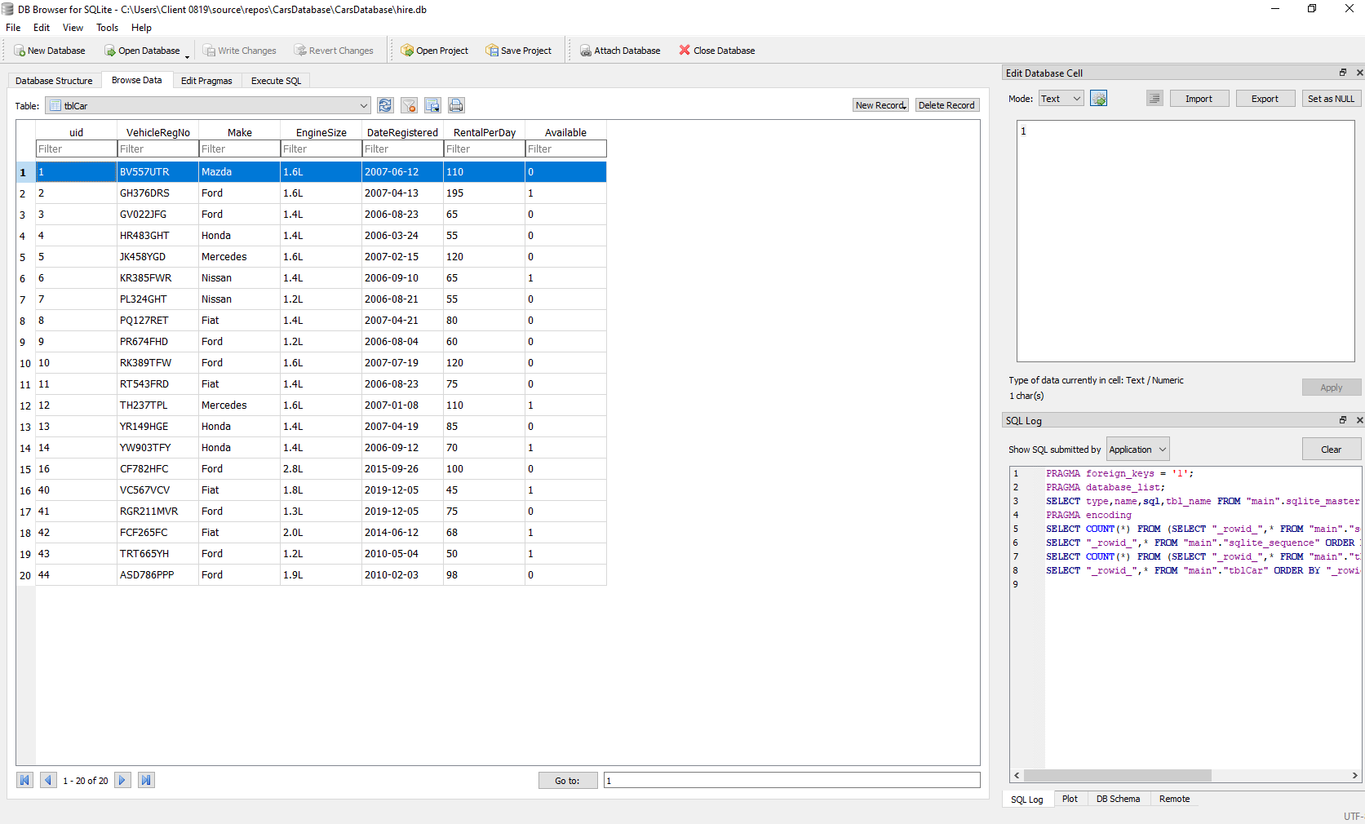TC01 – Screen FrmCars – Show the first record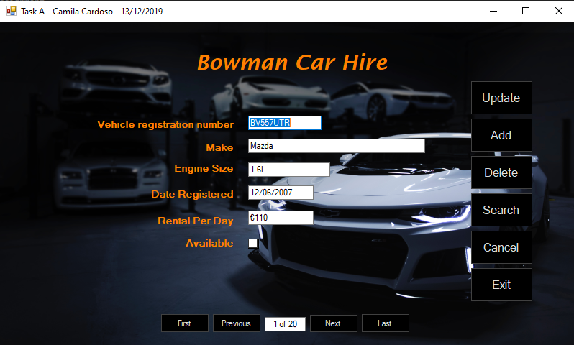

TC02 – Table tblCar – Second Record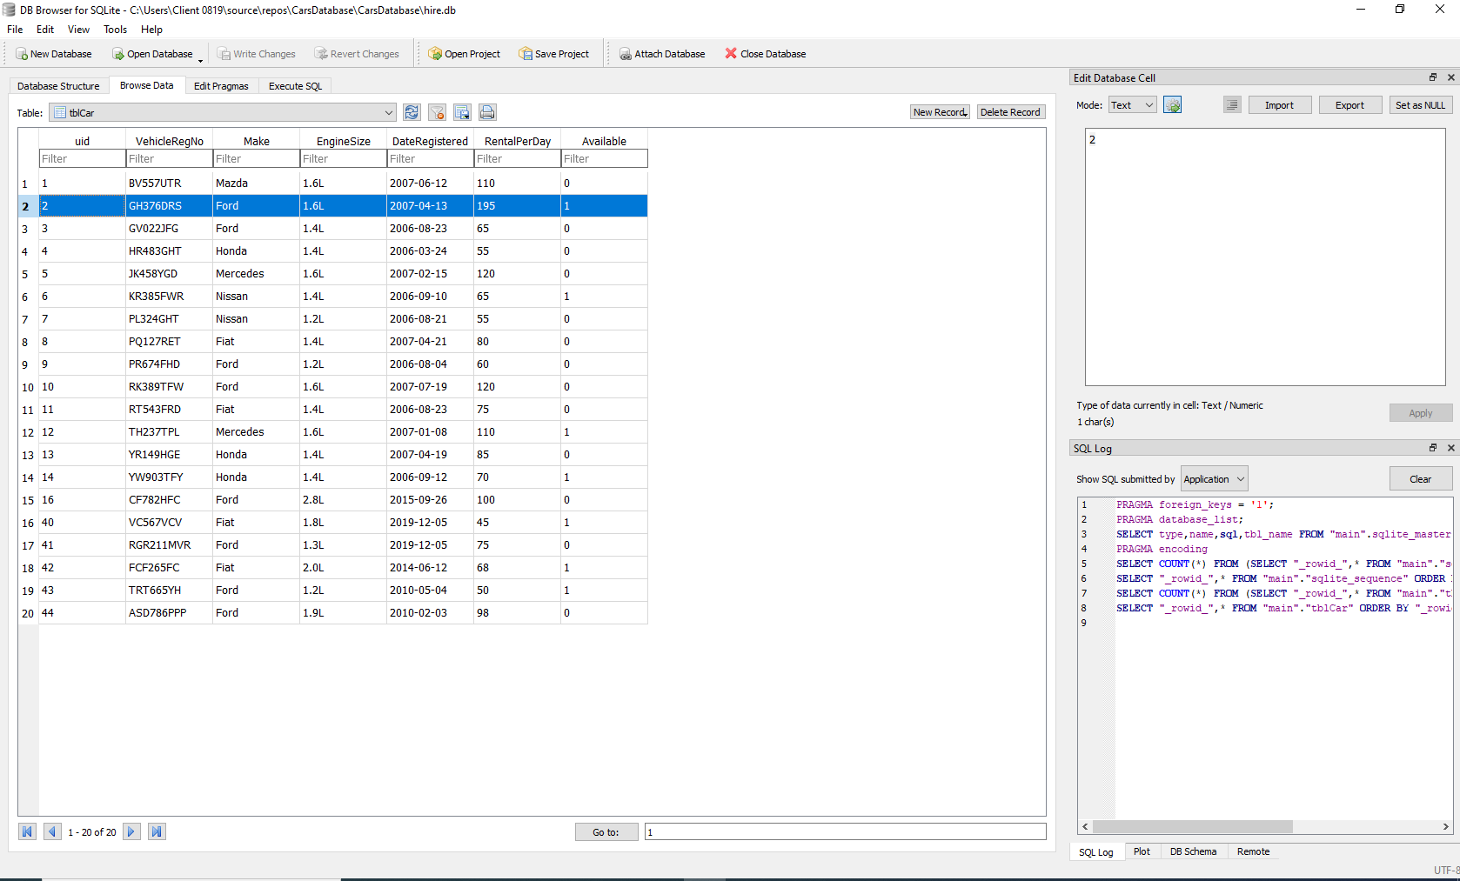

TC02 – Screen FrmCars – Next - Show the second record 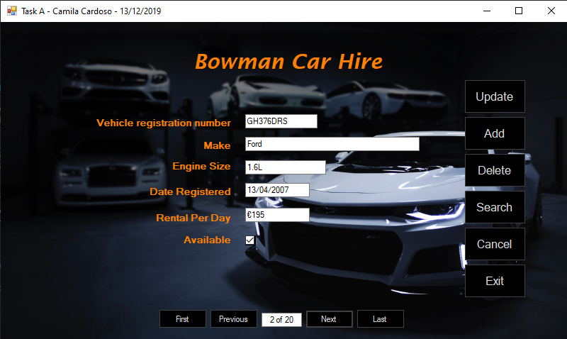

TC03 – Table tblCar – Last Record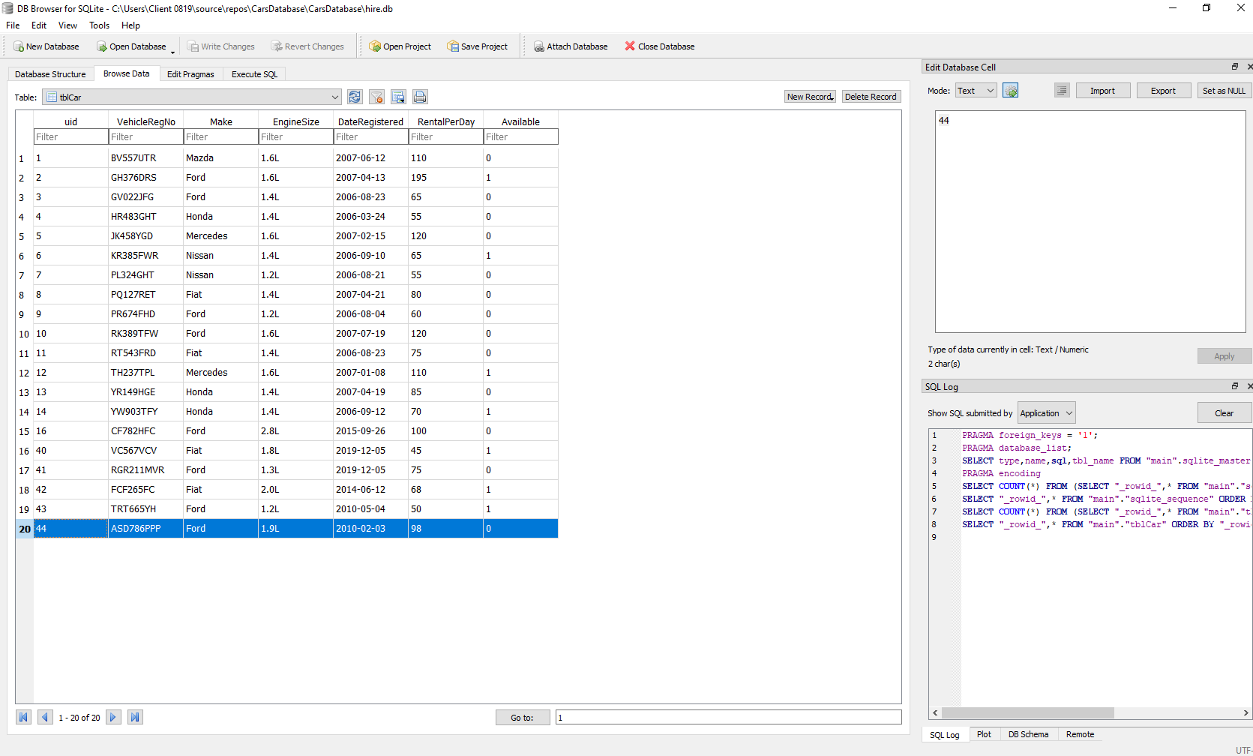TC03 – Screen FrmCars – Last - Show the last record 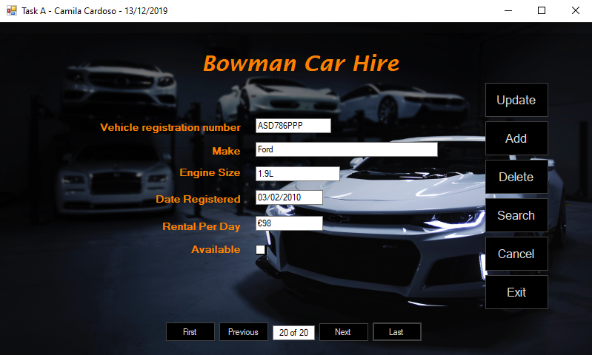TC04 – Table tblCar – Previous Record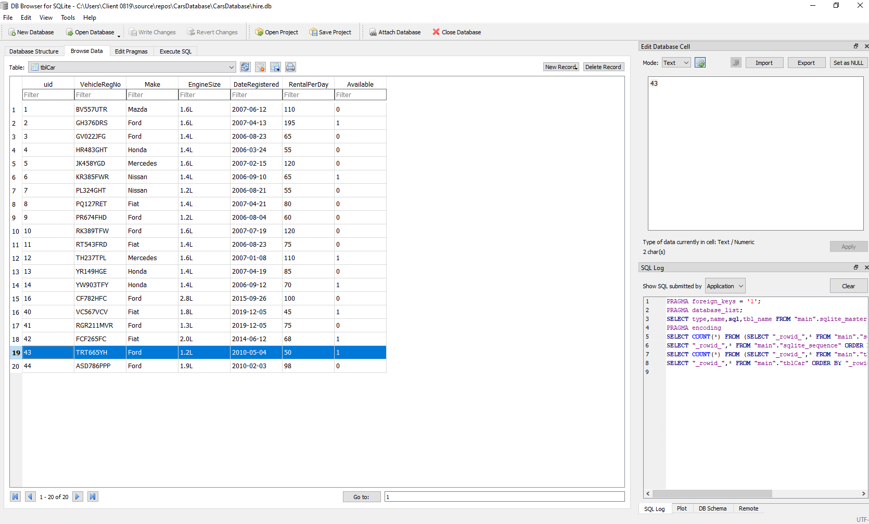TC04 – Screen FrmCars – Previous – Show the previous record 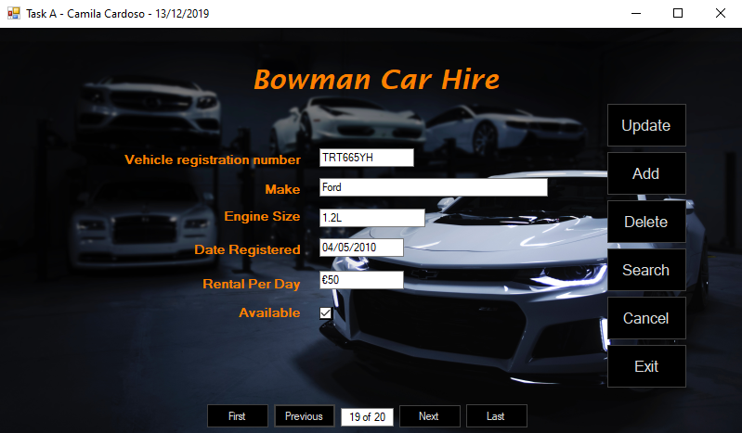TC05 – Table tblCar – First Record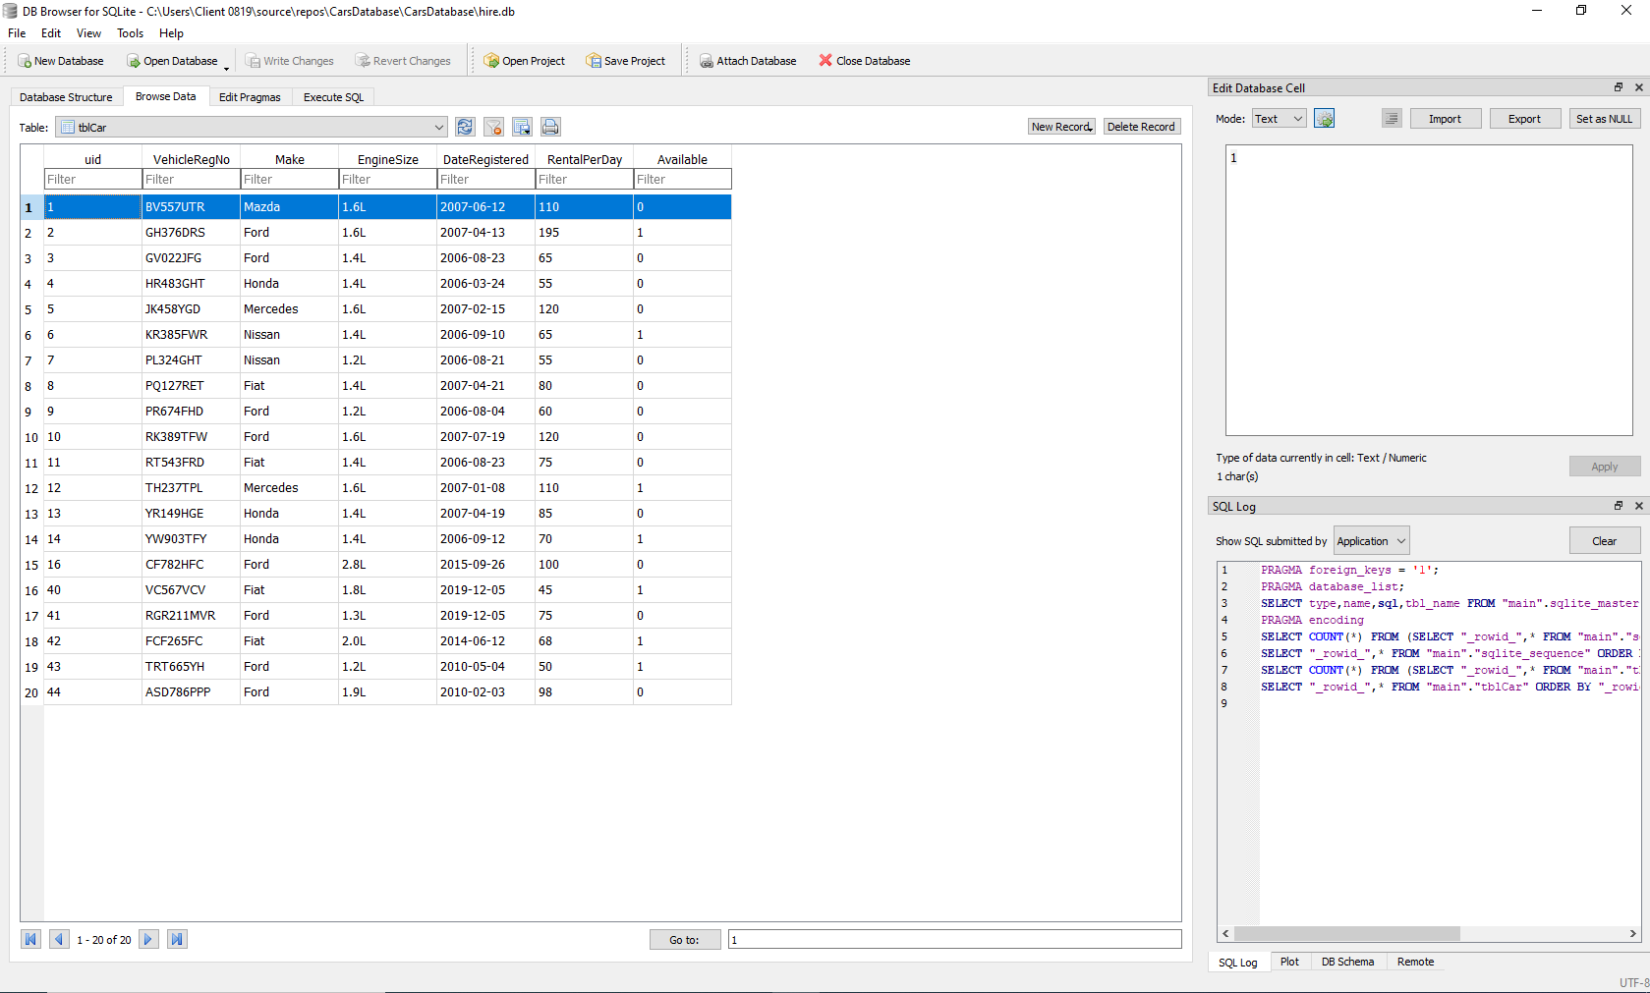TC05 – Screen FrmCars – First – Show the first record 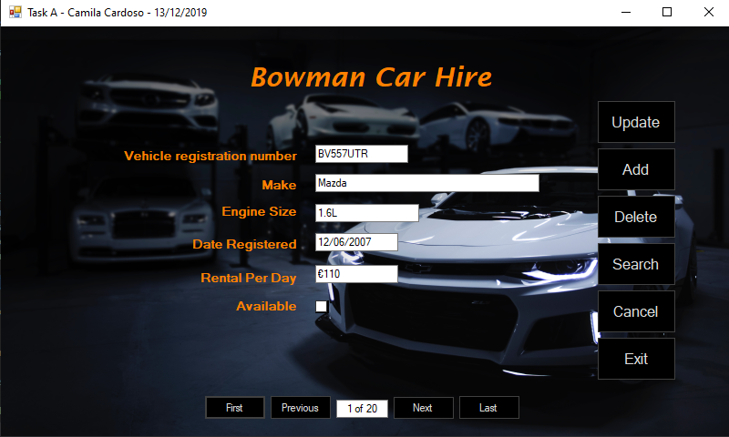TC06 – Screen FrmCars – Update – Field: Make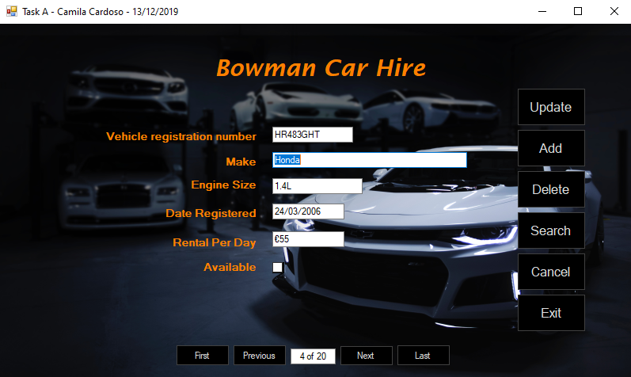

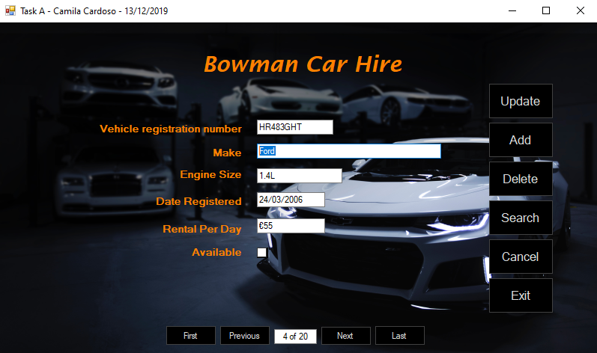

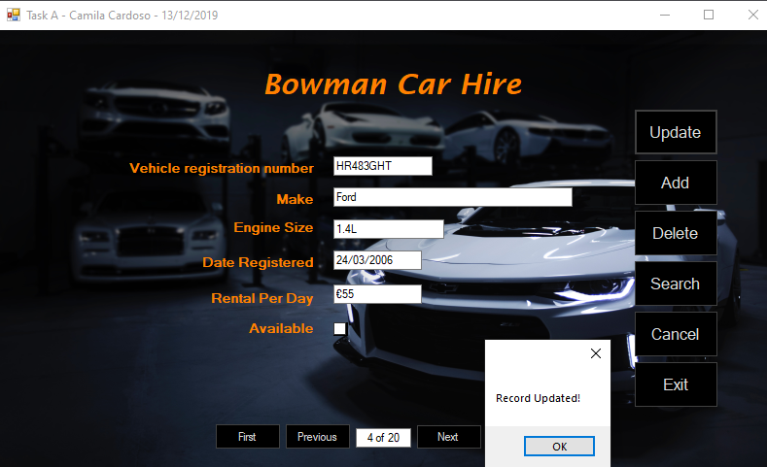TC06 – Table tblCar – Record Updated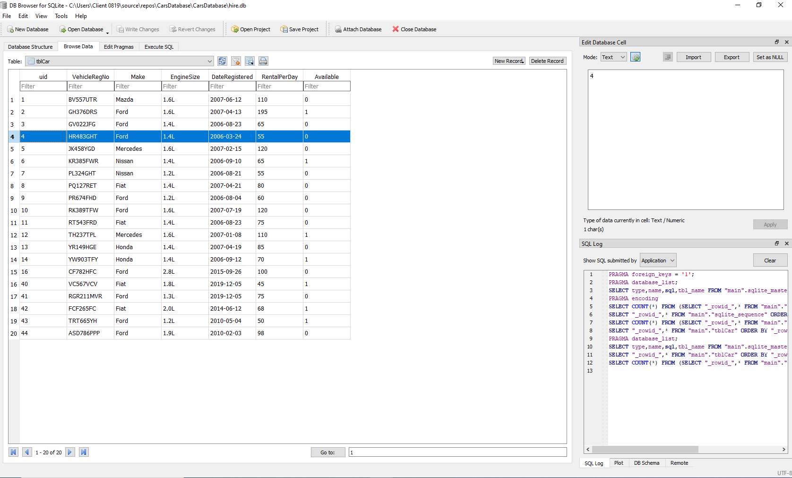TC07 – Screen FrmCars – Update – Field: Engine 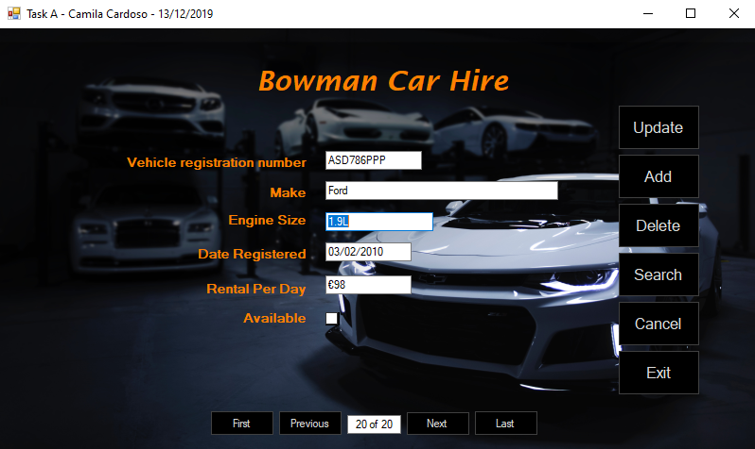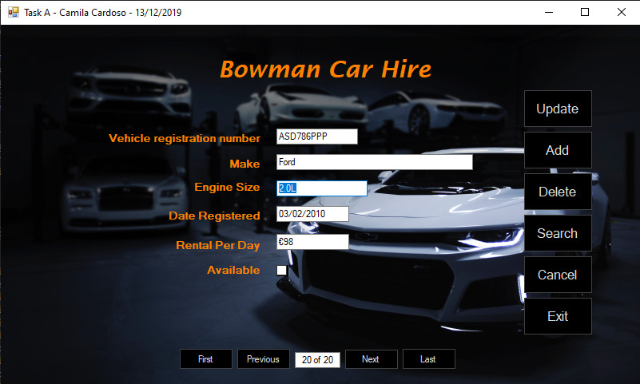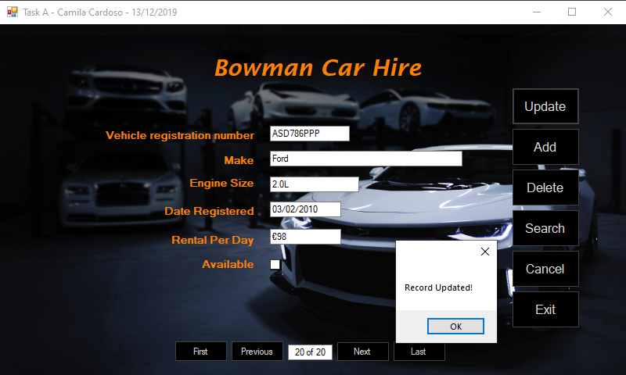TC07 – Table tblCar – Record Updated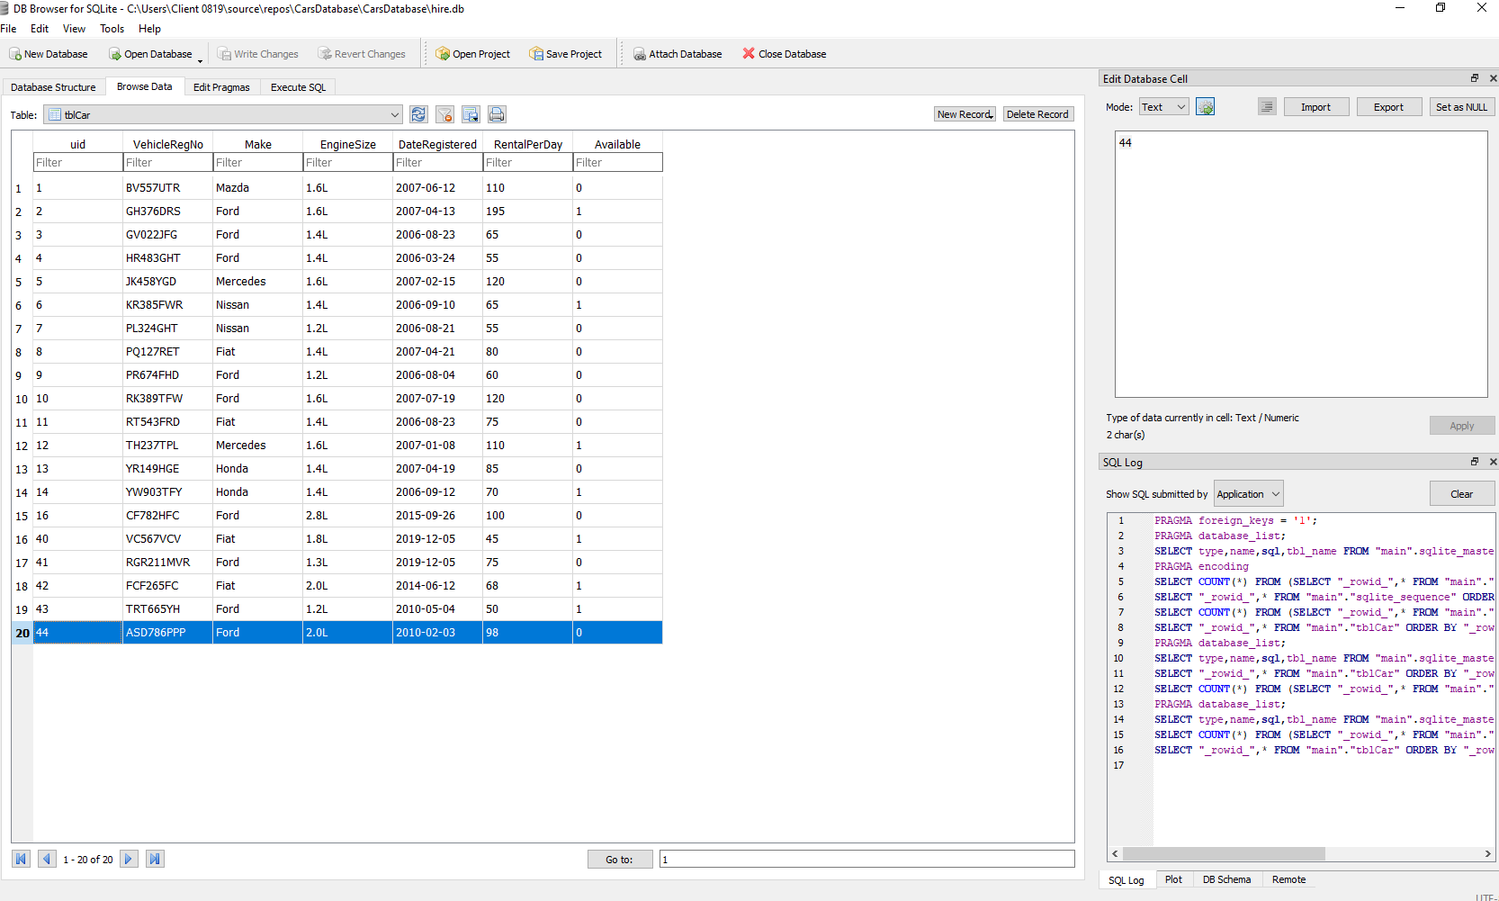TC08 – Screen FrmCars – Update – Field: Data Registered 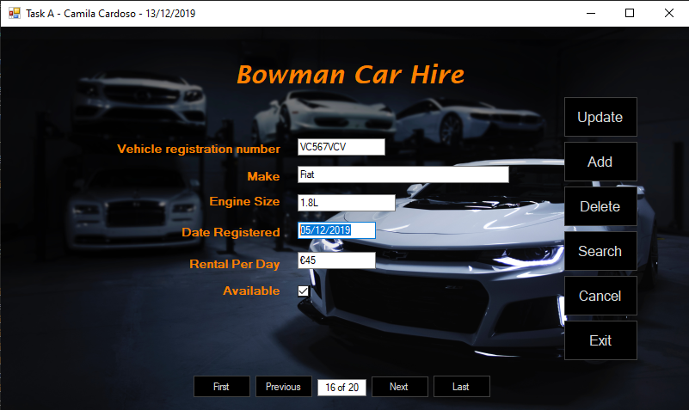

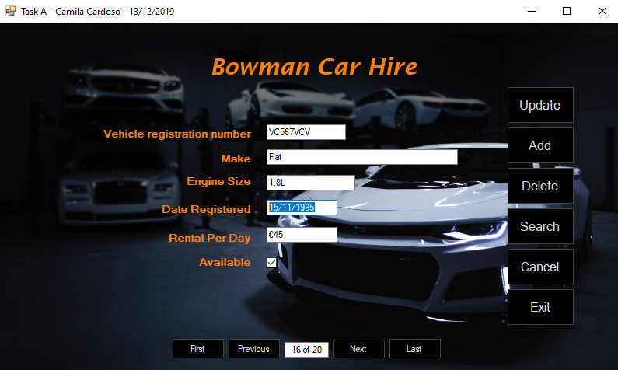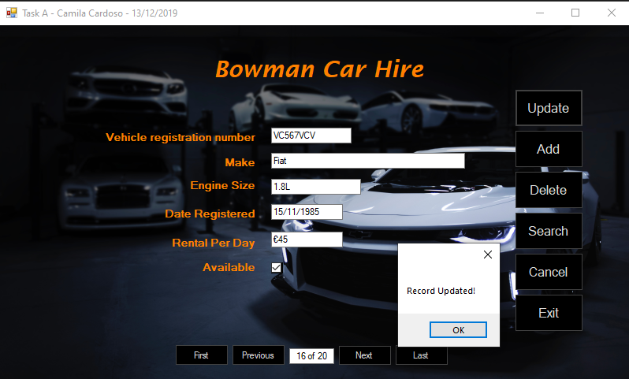TC08 – Table tblCar – Record Updated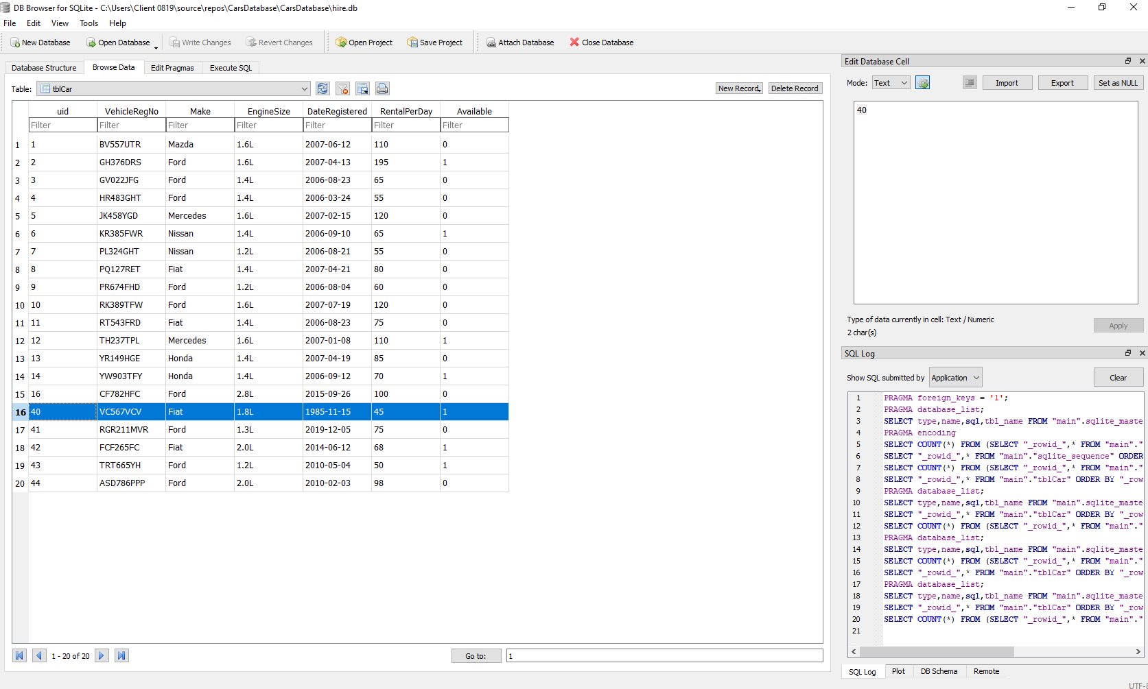TC09 – Screen FrmCars – Update – Field: Rental Per Day 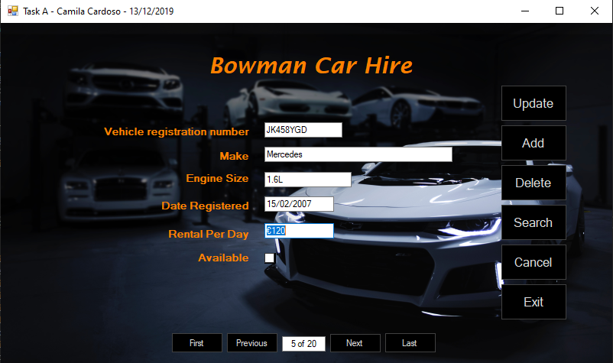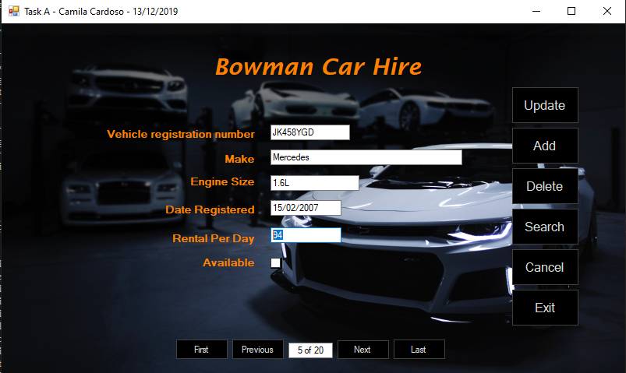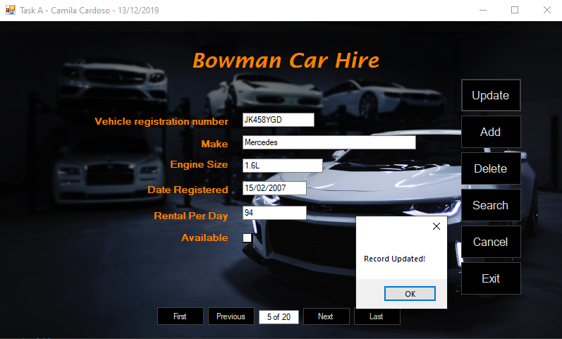TC09 – Table tblCar – Record Updated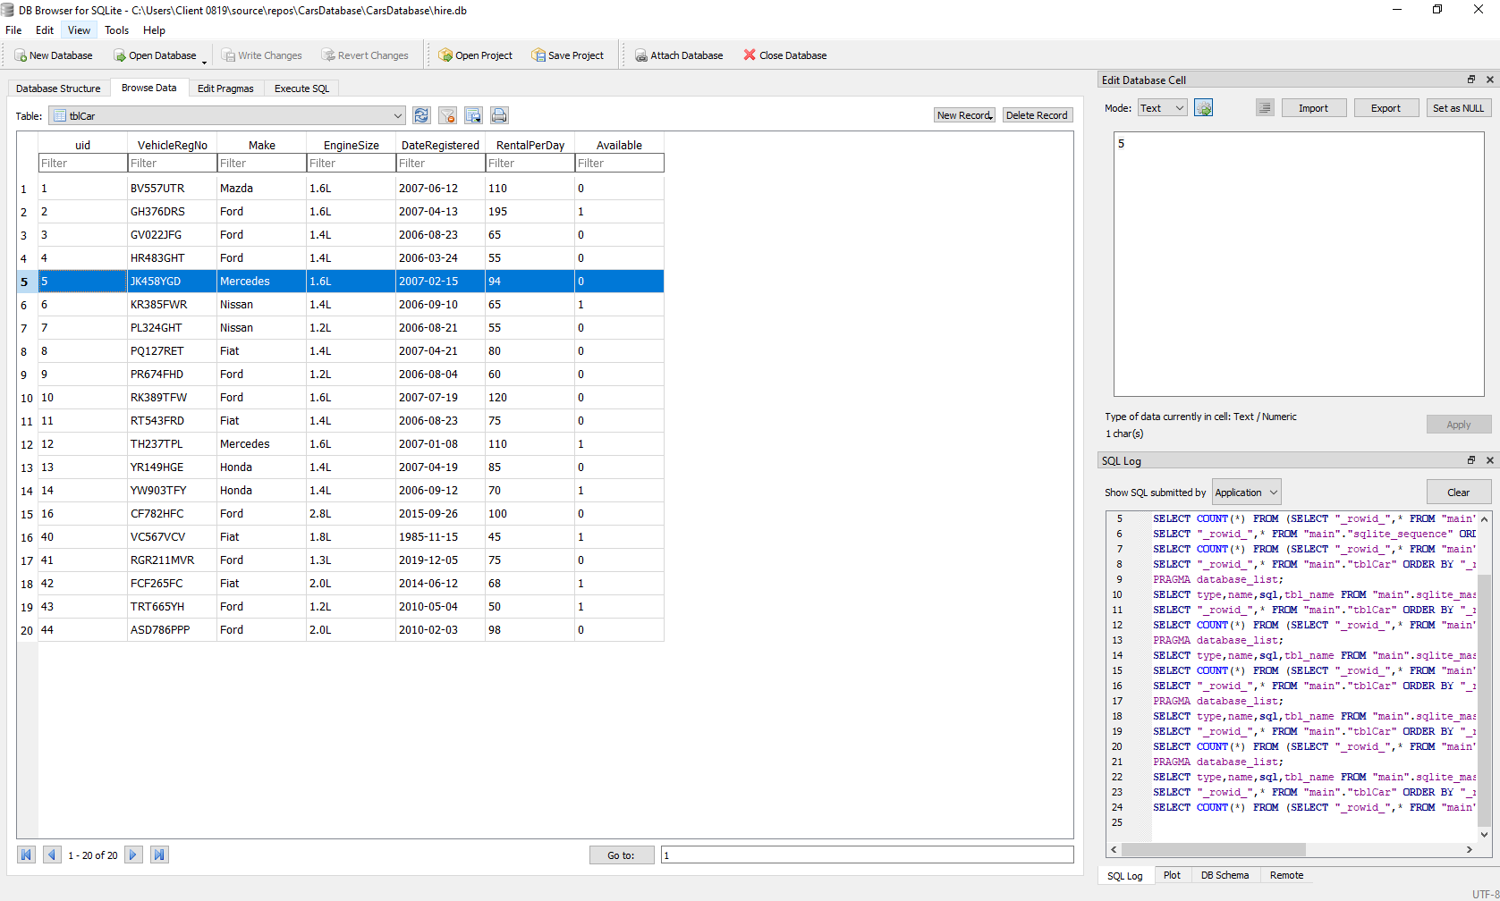TC10 – Screen FrmCars – Update – Invalid Field: Make 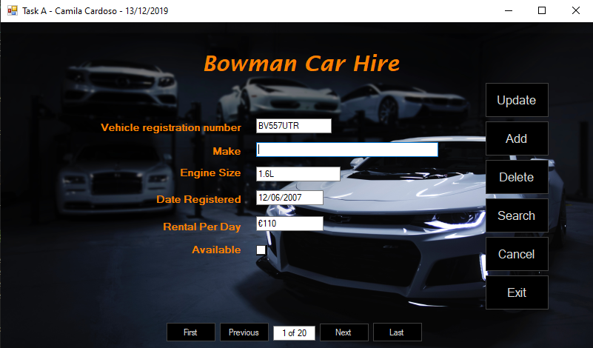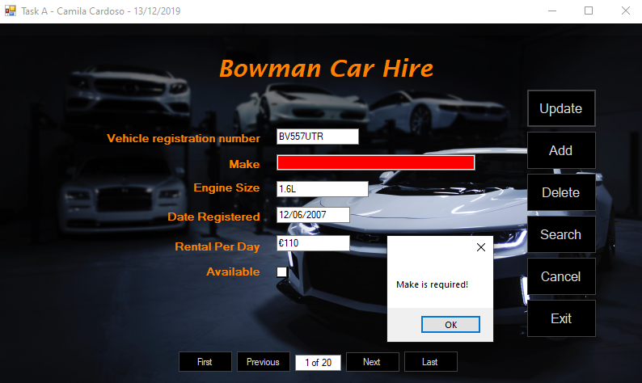TC10 – Table tblCar – Record has not Updated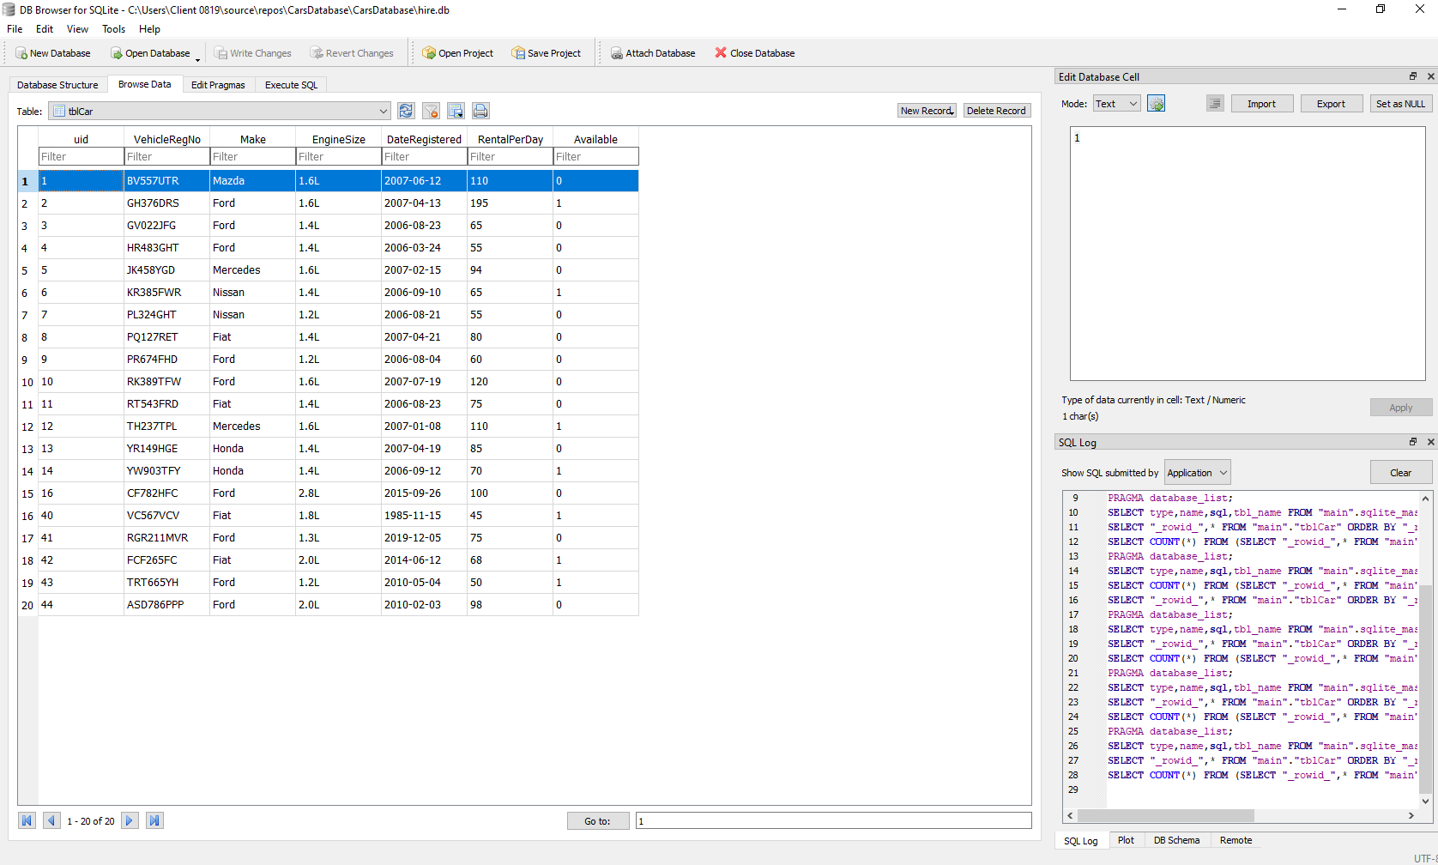TC11 – Screen FrmCars – Update – Invalid Field: Engine Size 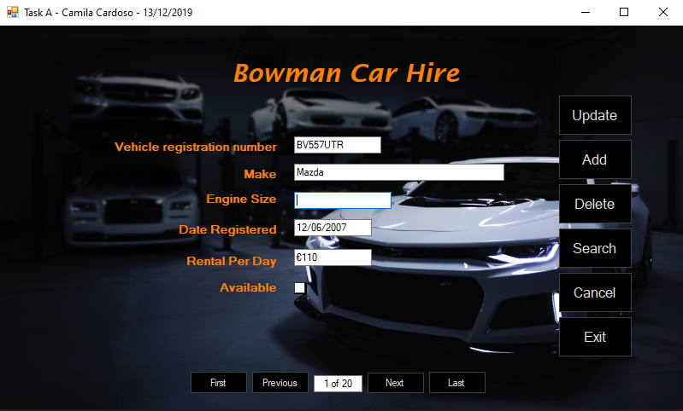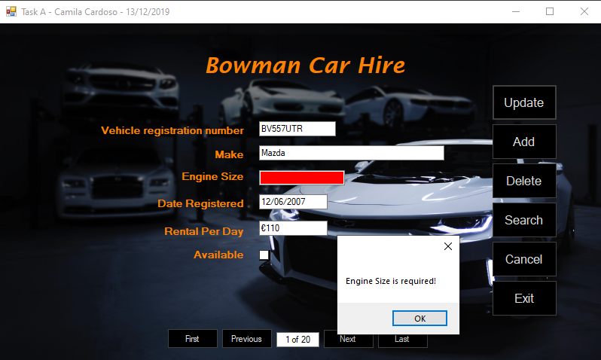TC11 – Table tblCar – Record has not Updated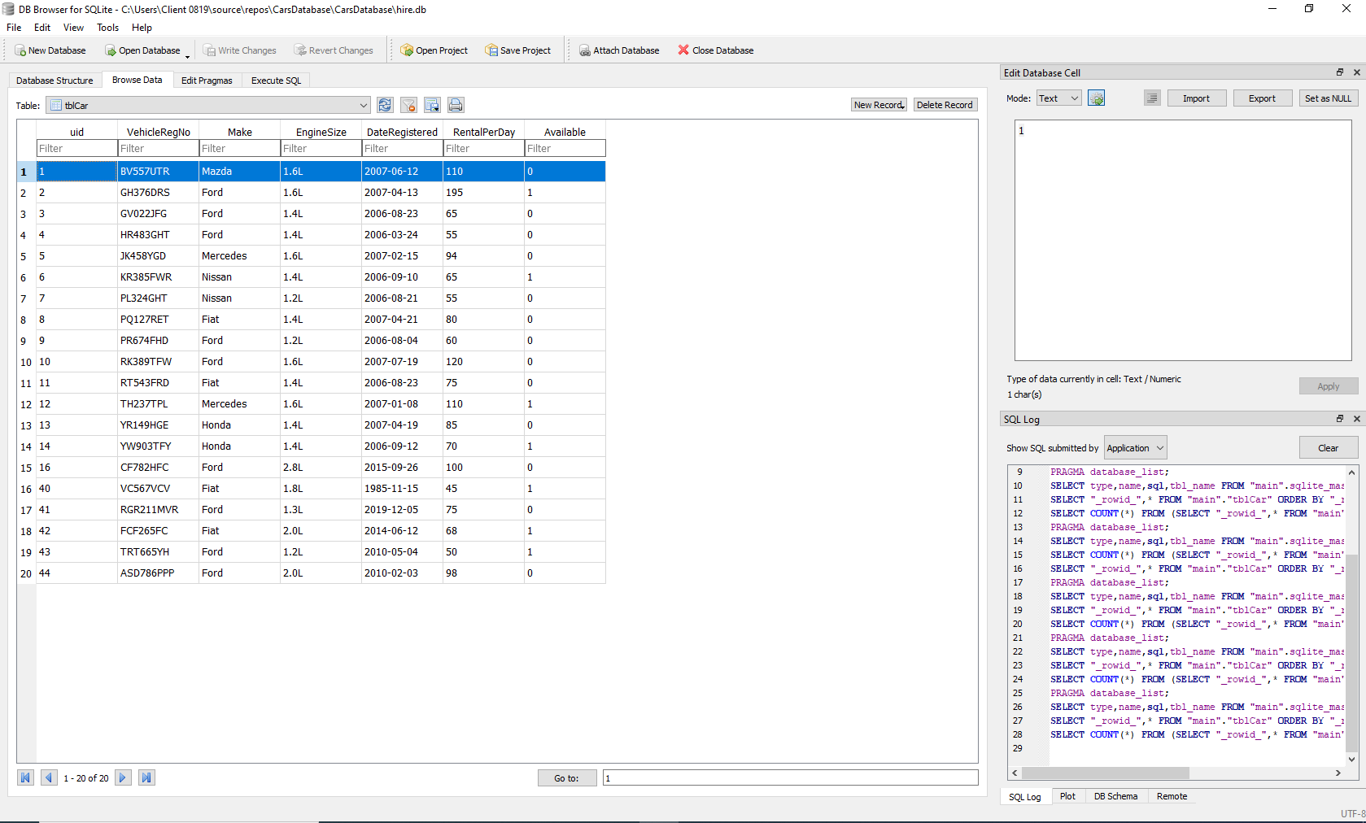TC12 – Screen FrmCars – Update – Invalid Field: Date Registered 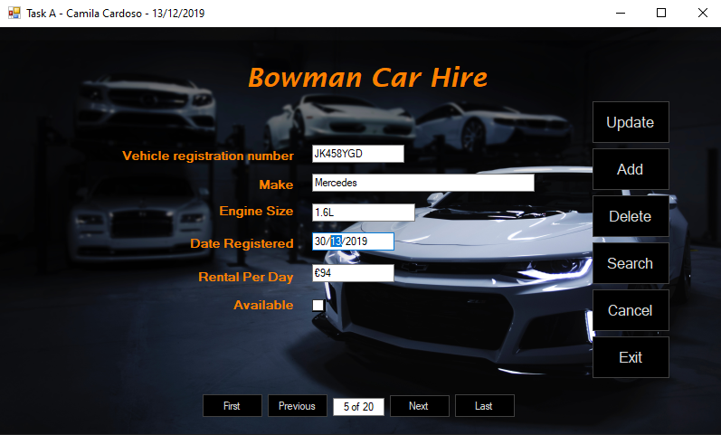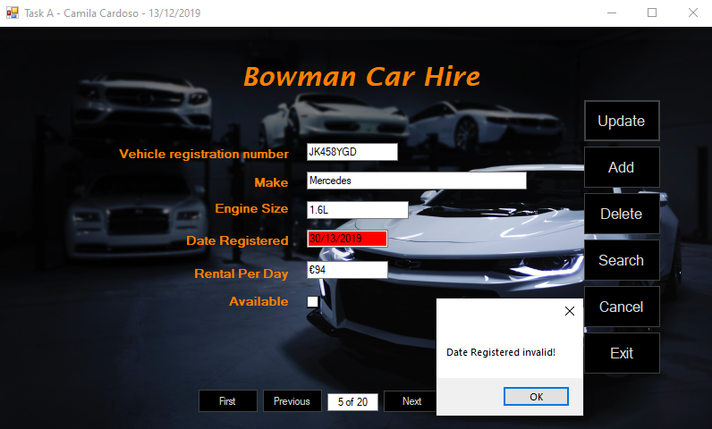TC12 – Table tblCar – Record has not Updated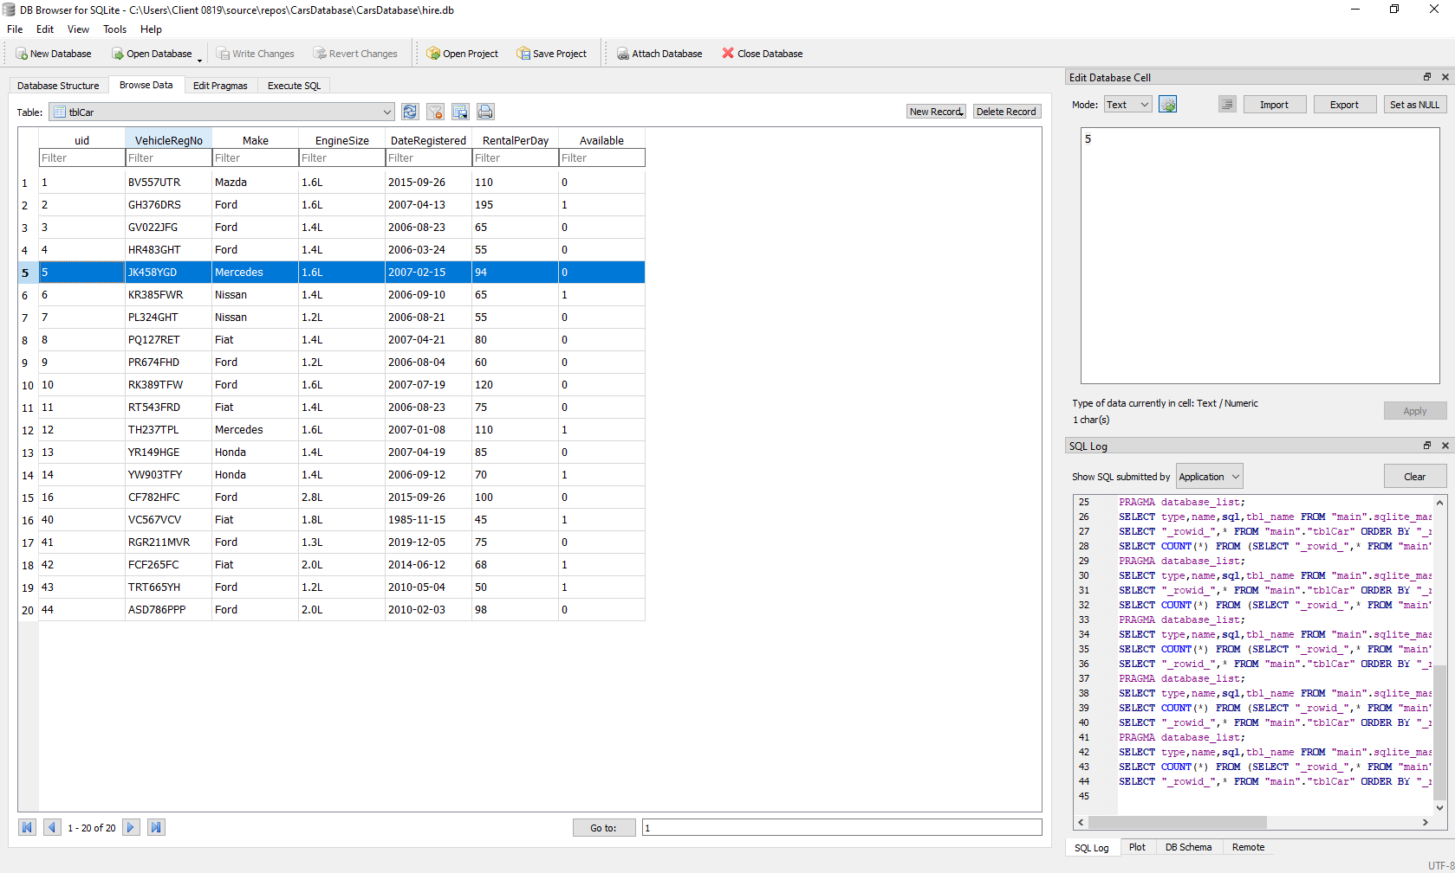

TC13 – Screen FrmCars – Update – Invalid Field: Rental Per Day 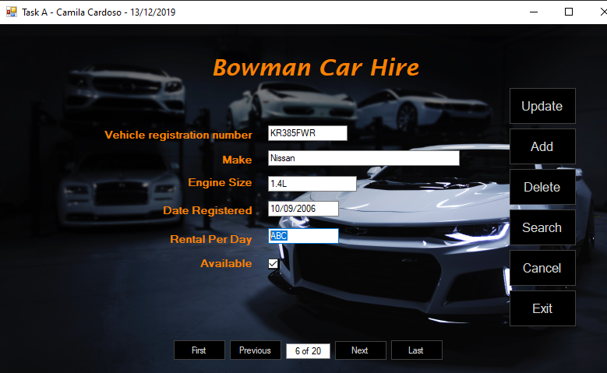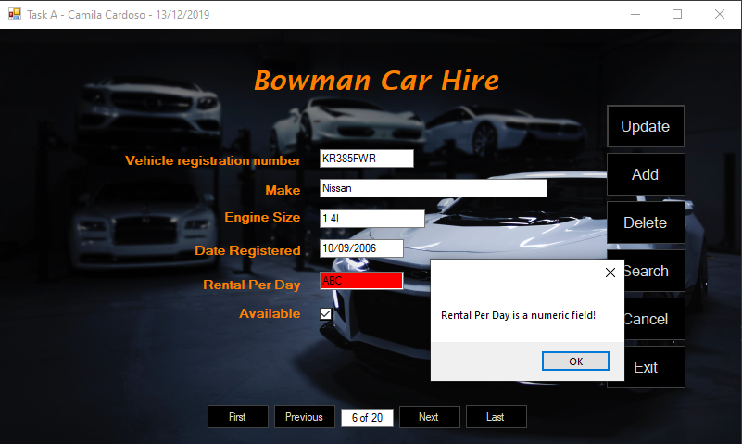TC13 – Table tblCar – Record has not Updated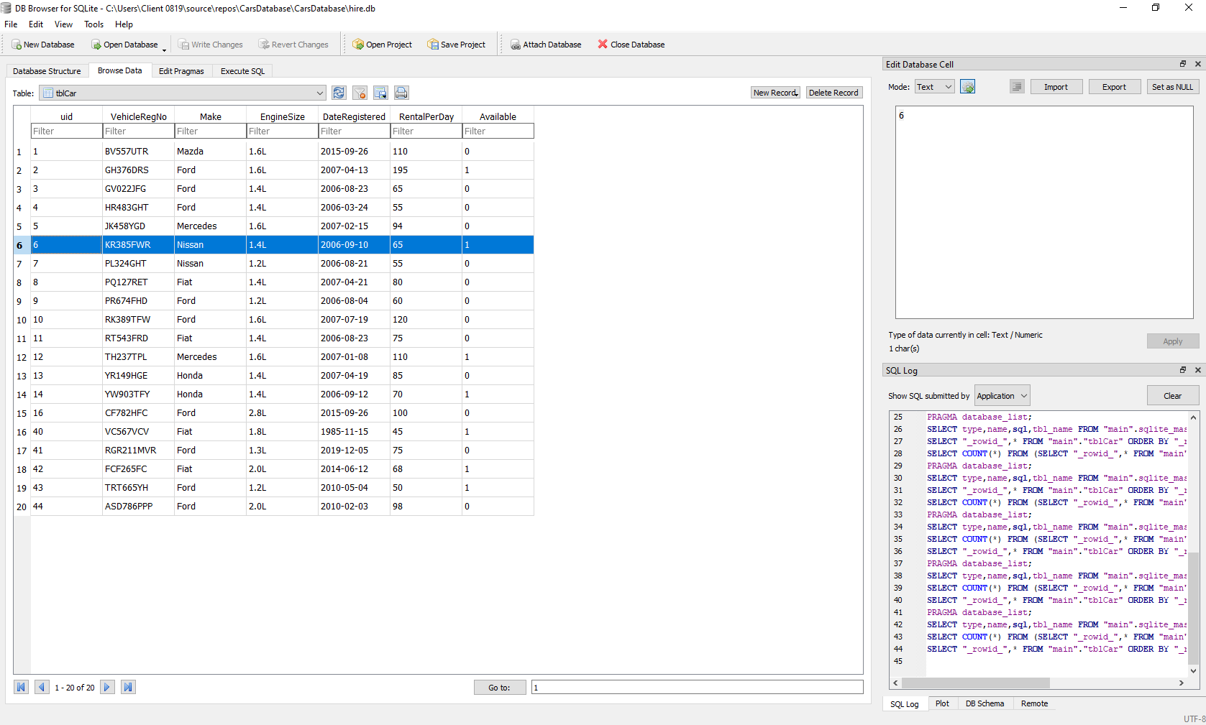TC14 – Screen FrmCars – Insert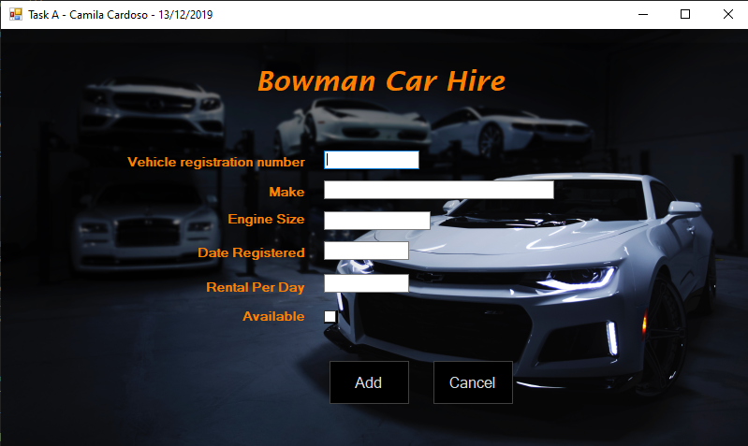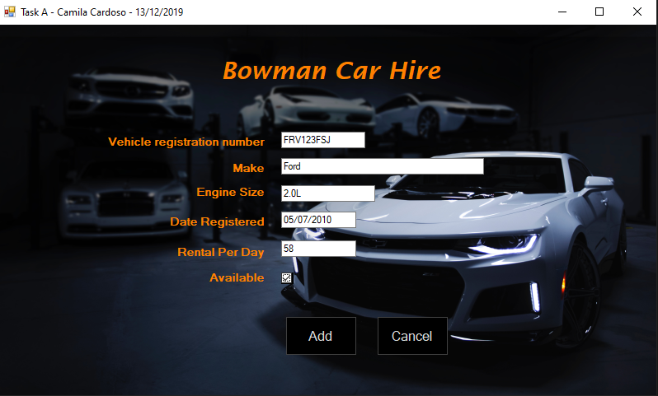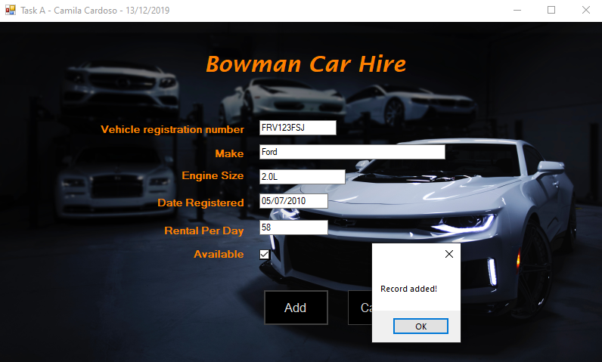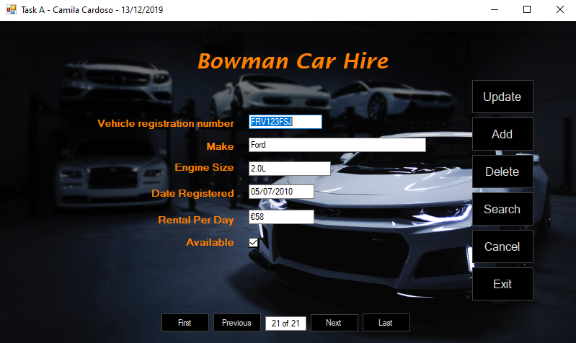TC14 – Table tblCar – Record Add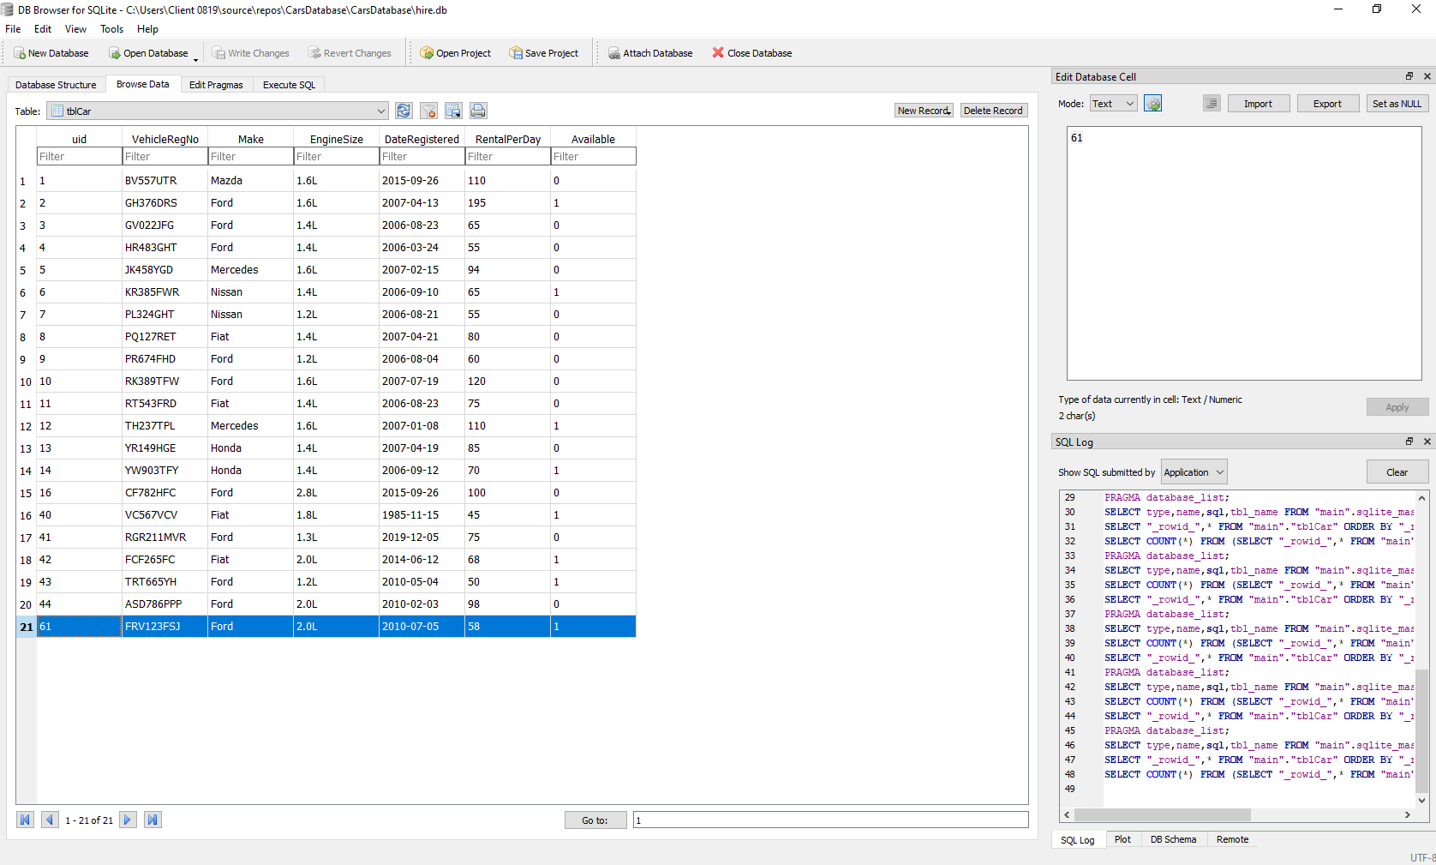TC15 – Screen FrmCars – Insert – Invalid Field: Vehicle registration number 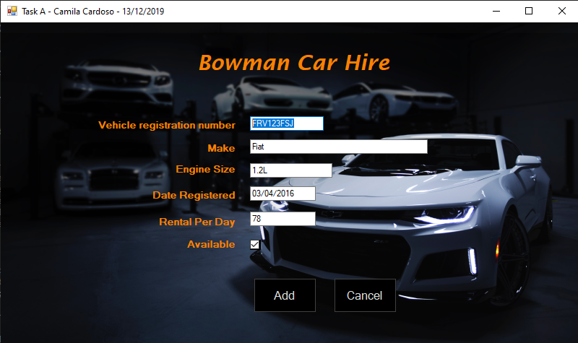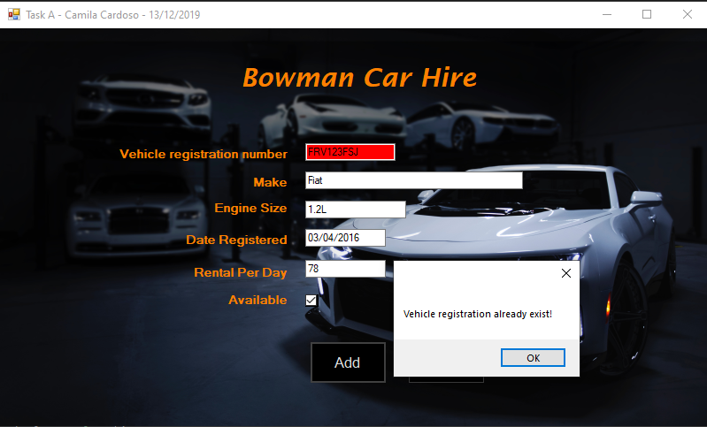TC15 – Table tblCar – Record has not Inserted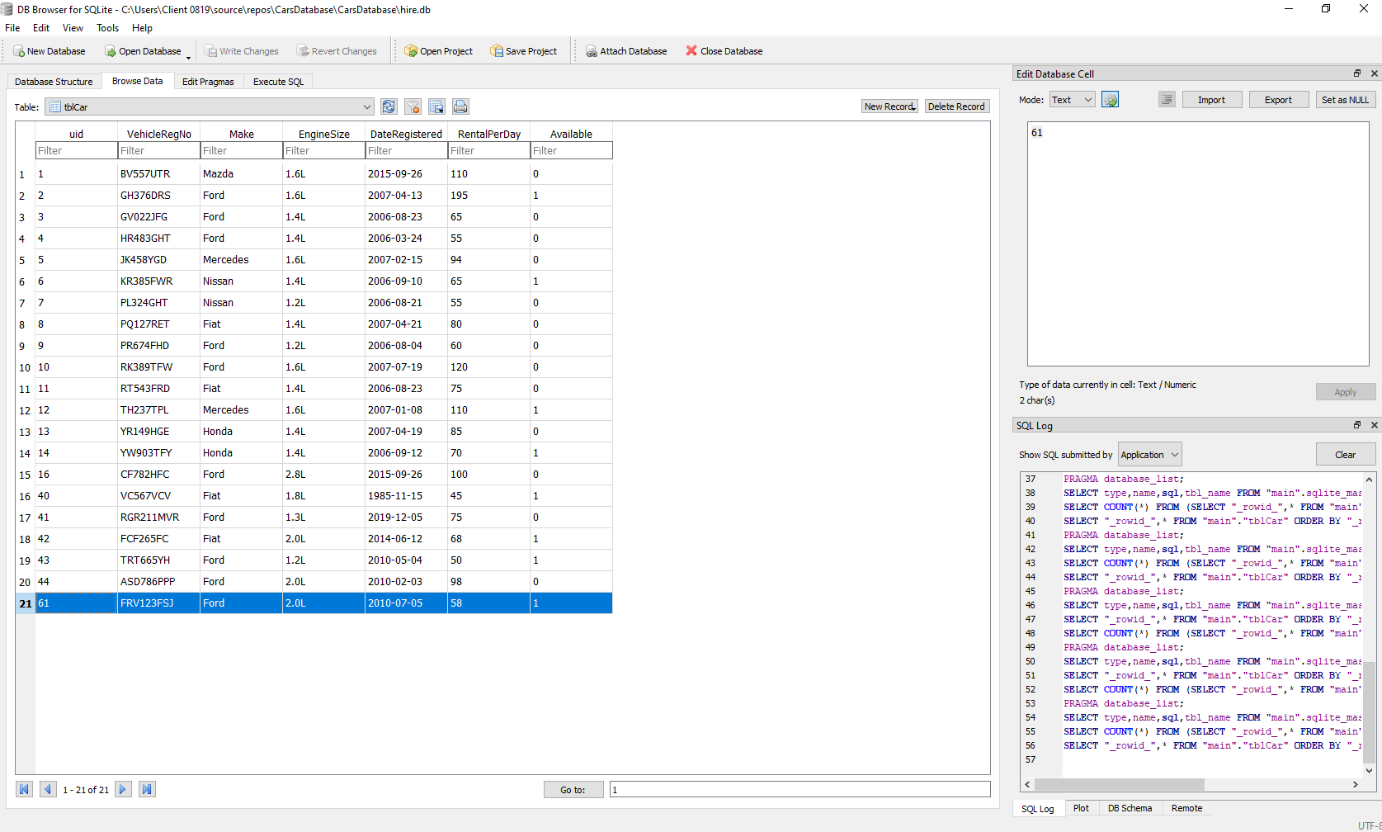TC16 – Screen FrmCars – Insert – Invalid Field: Make 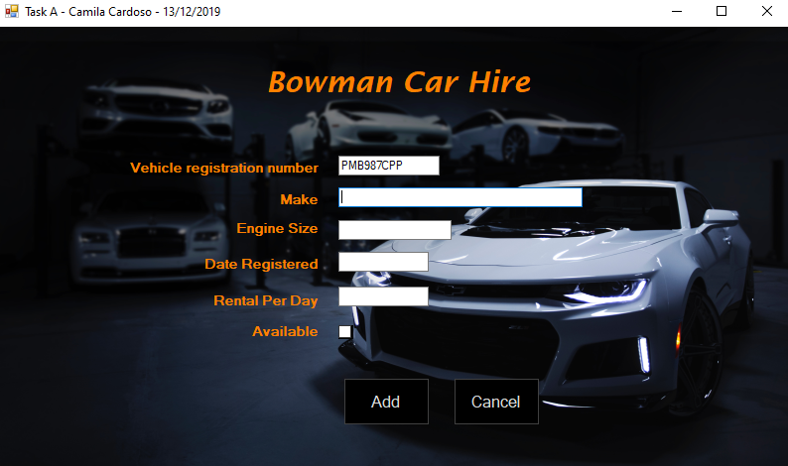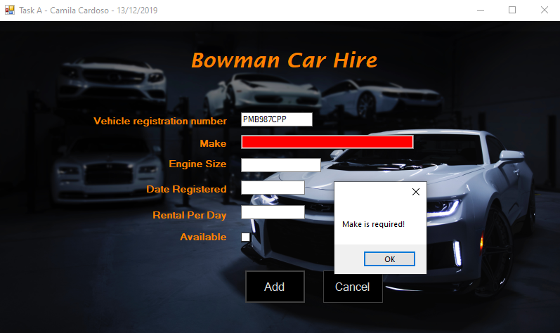TC16 – Table tblCar – Record has not Inserted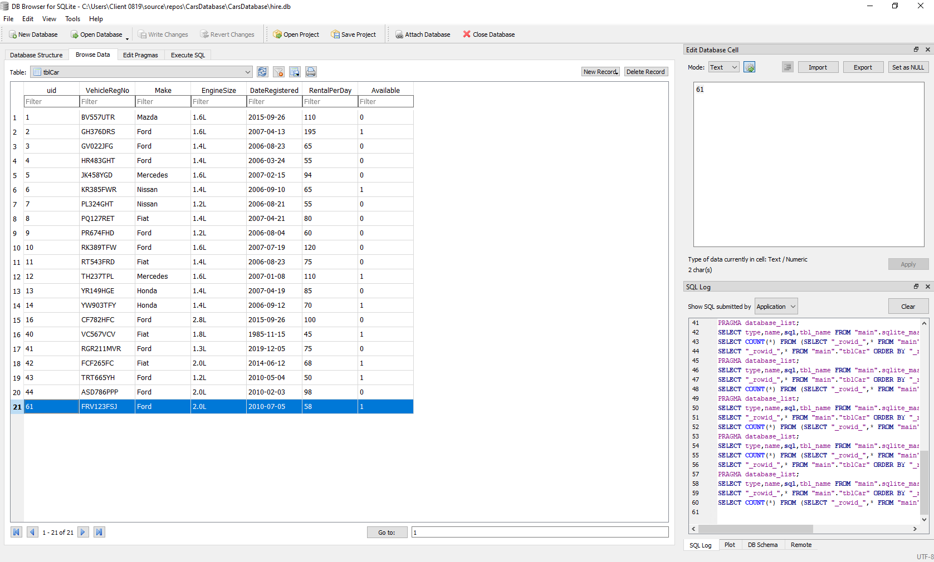TC17 – Screen FrmCars – Insert – Invalid Field: Engine Size 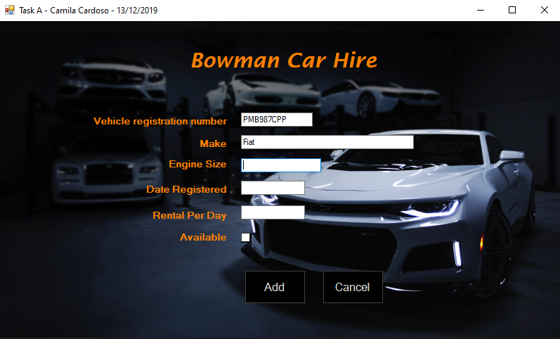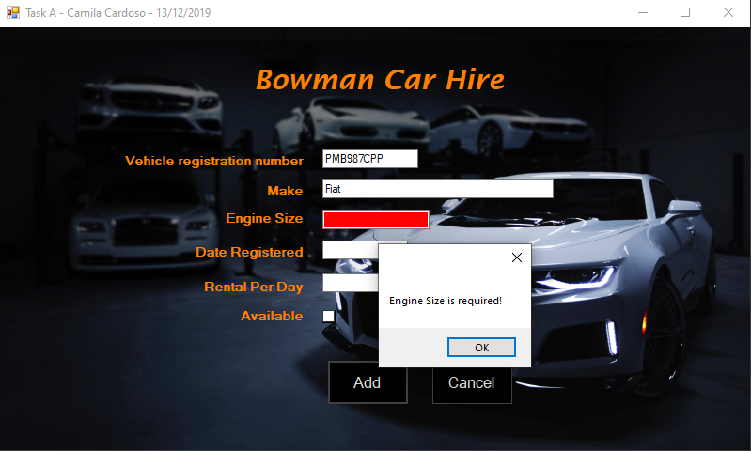TC17 – Table tblCar – Record has not Inserted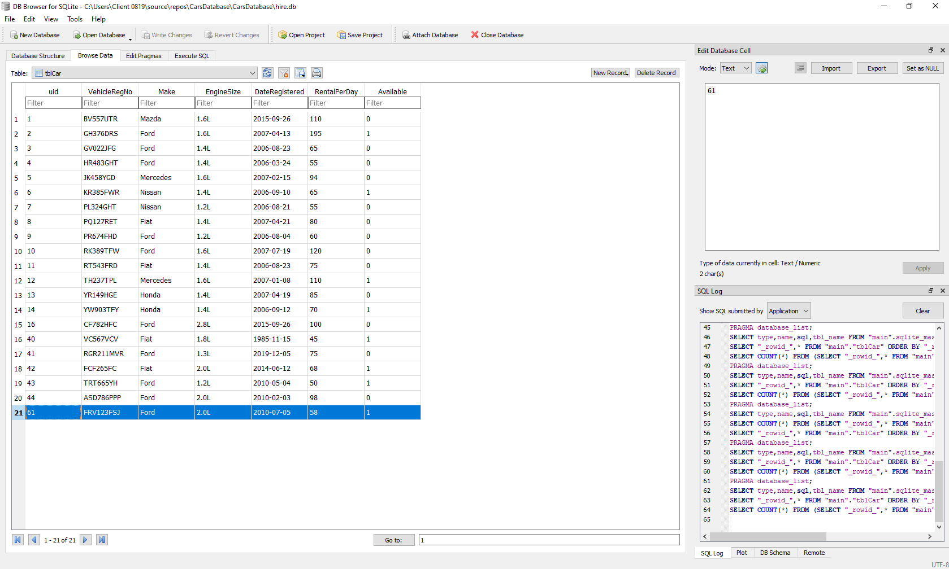TC18 – Screen FrmCars – Insert – Invalid Field: Date Registered 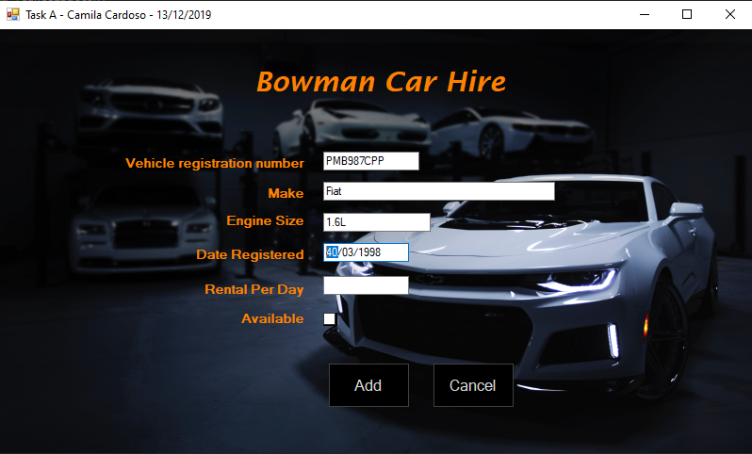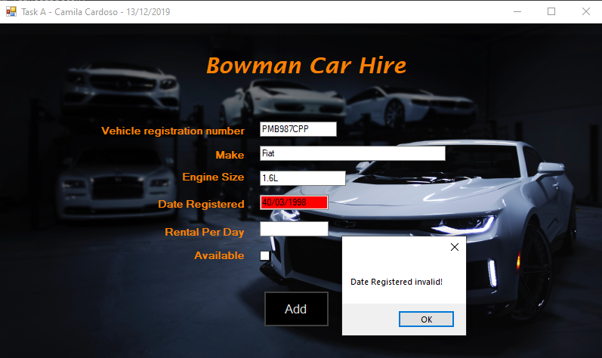TC18 – Table tblCar – Record has not Inserted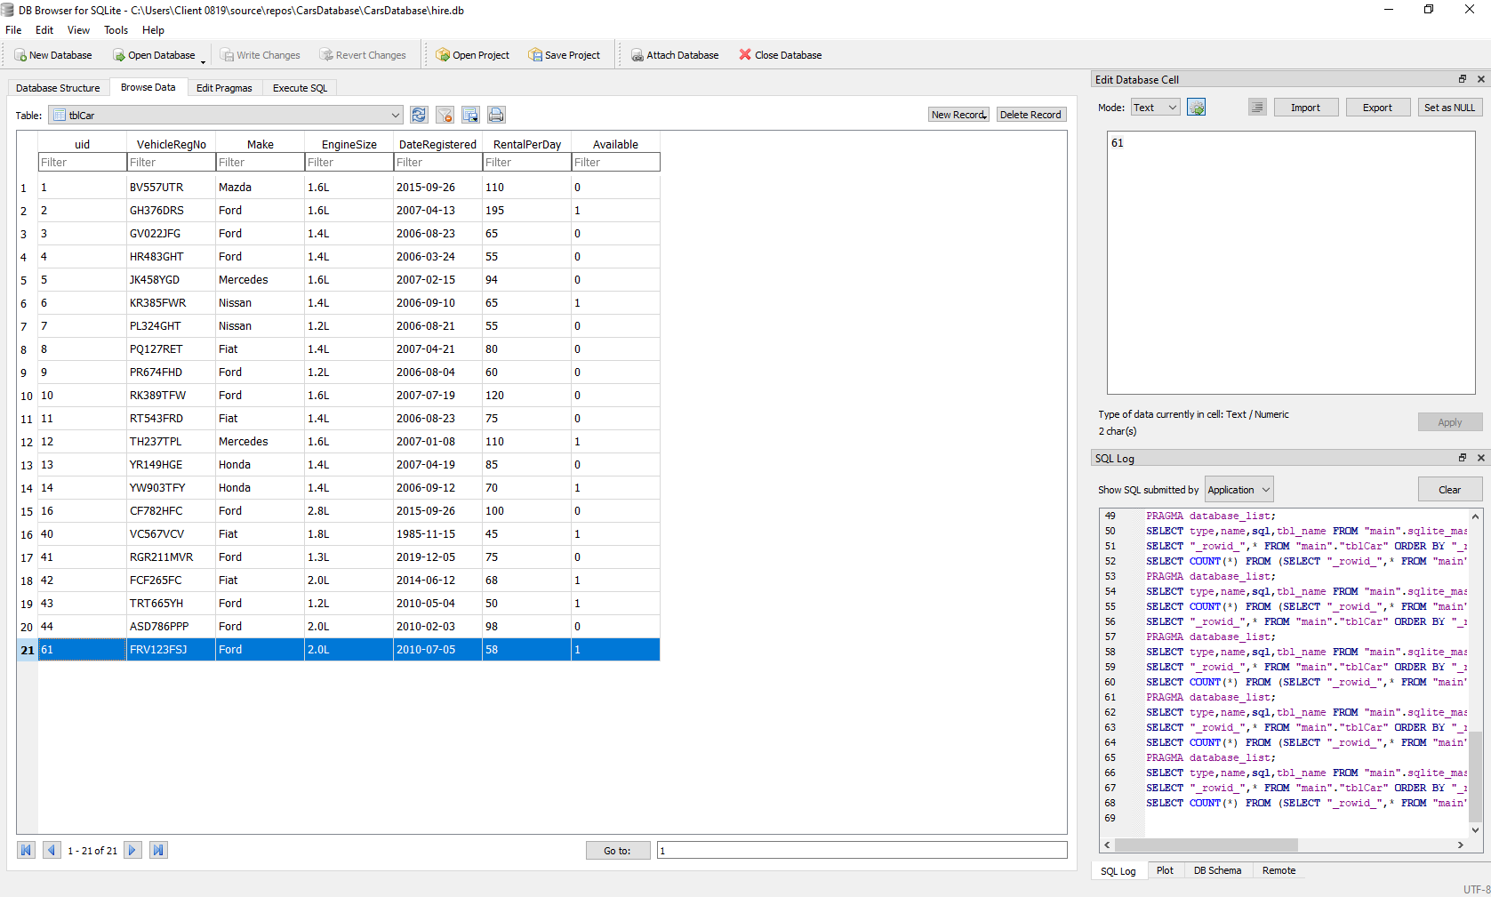TC19 – Screen FrmCars – Insert – Invalid Field: Rental Per Day 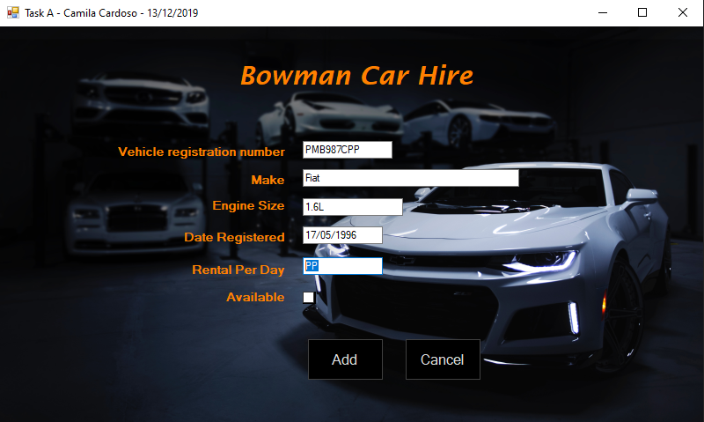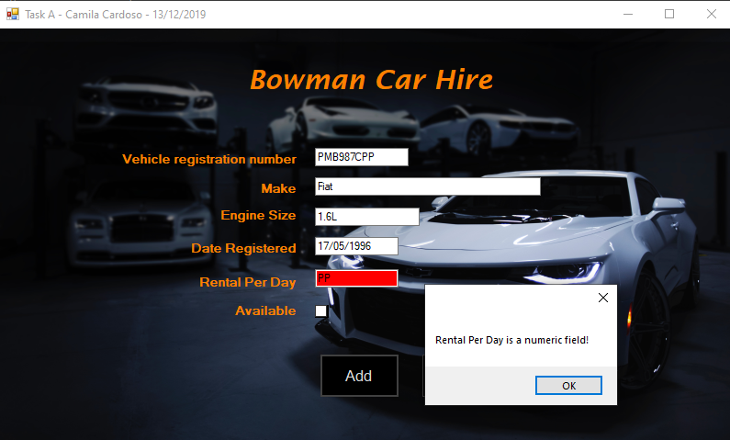TC19 – Table tblCar – Record has not Inserted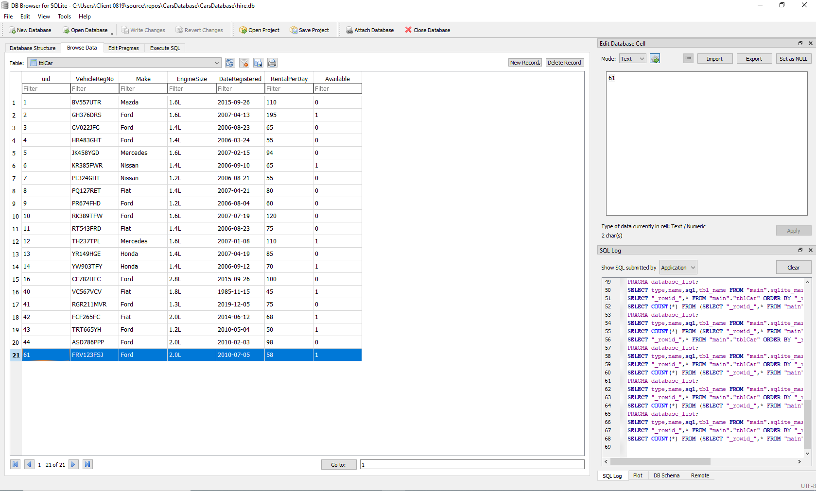TC20 – Screen FrmCars – Cancel the Insert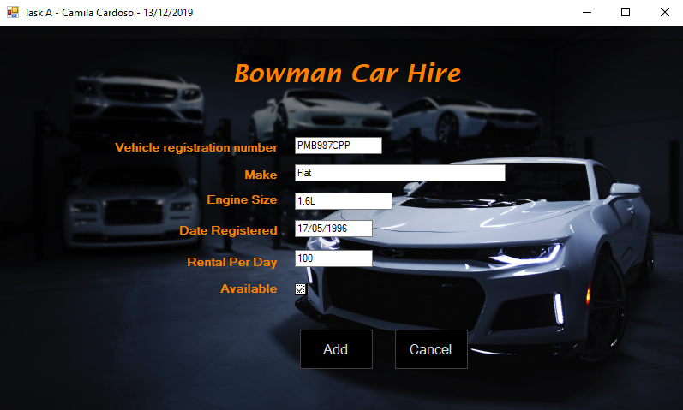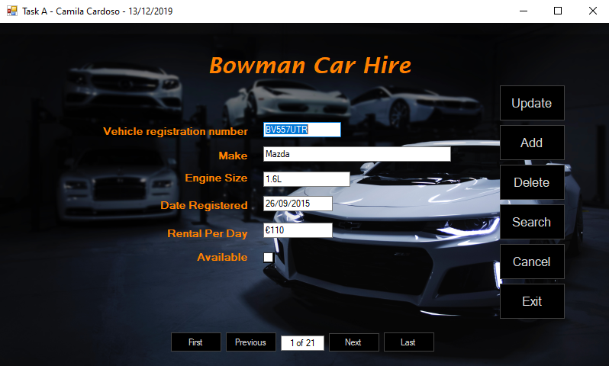TC20 – Table tblCar – Record has not Inserted TC21 – Screen FrmCars – Delete – Confirmation: Yes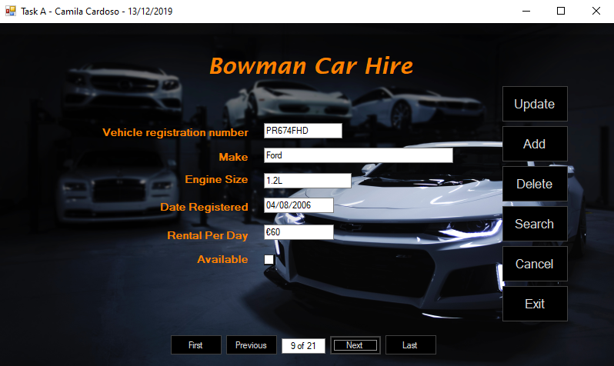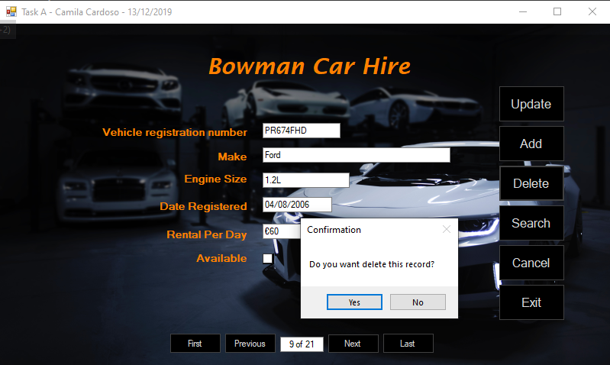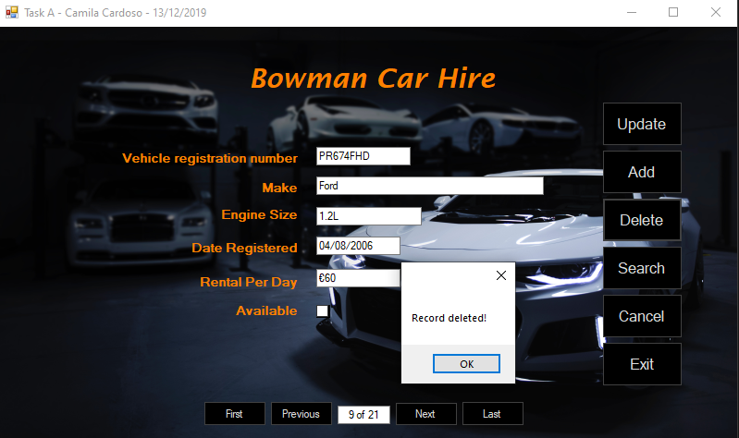

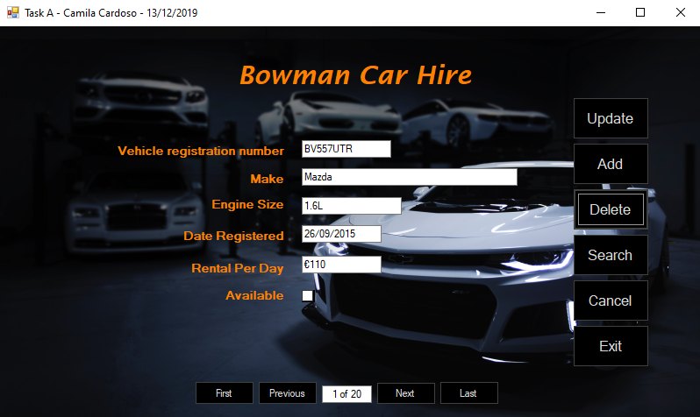

TC21 – Table tblCar – Before Delete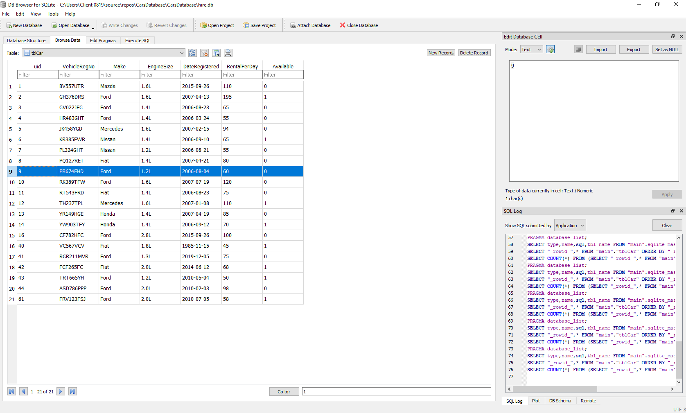TC21 – Table tblCar – After Delete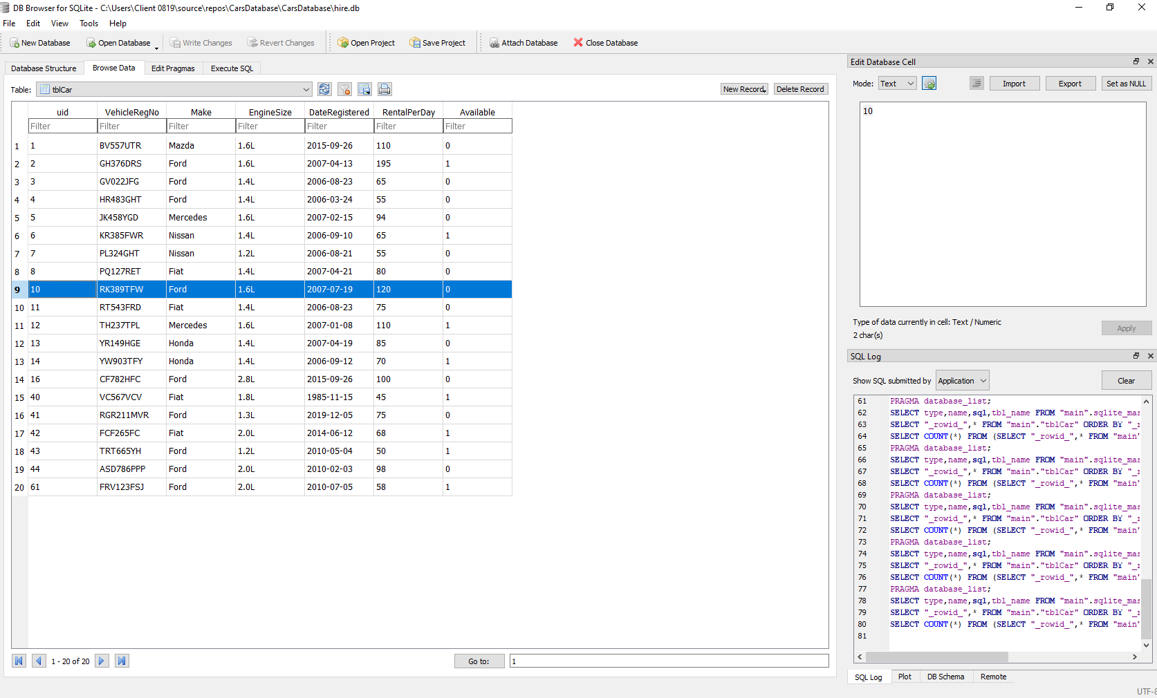TC22 – Screen FrmCars –Delete – Confirmation: No 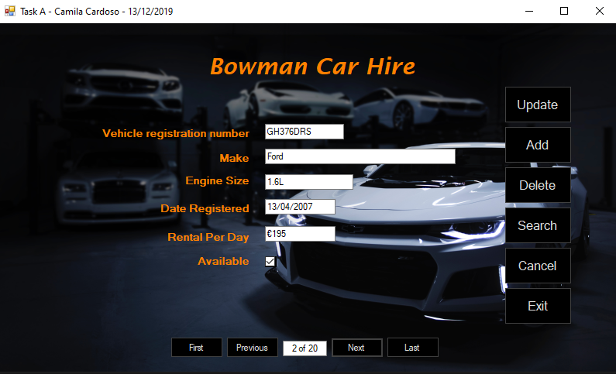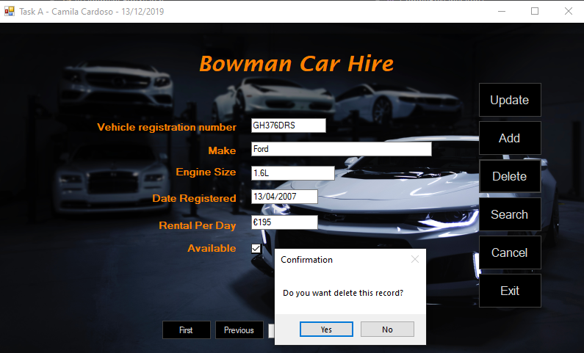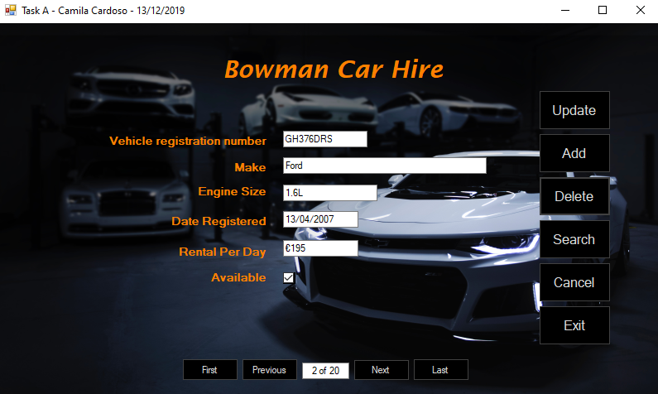TC22 – Table tblCar – After Delete – Confirmation: No 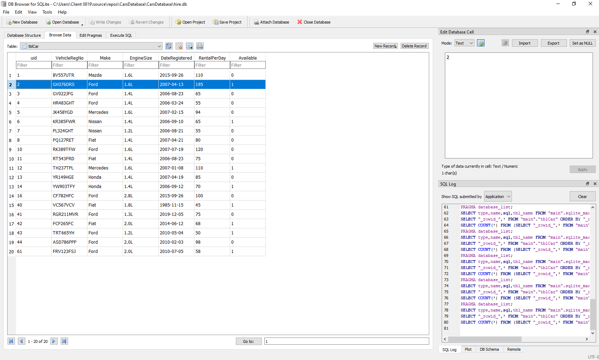TC23 – Screen FrmCars – Search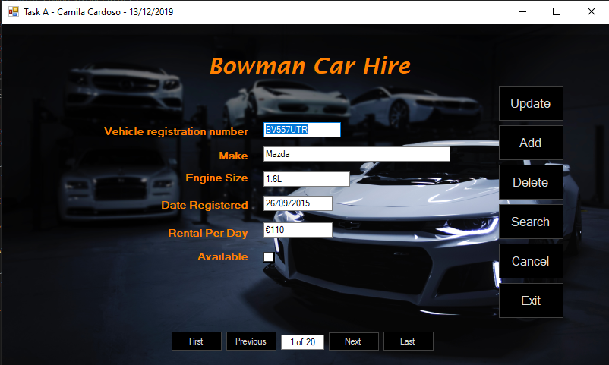TC23 – Screen FrmCars - Blocked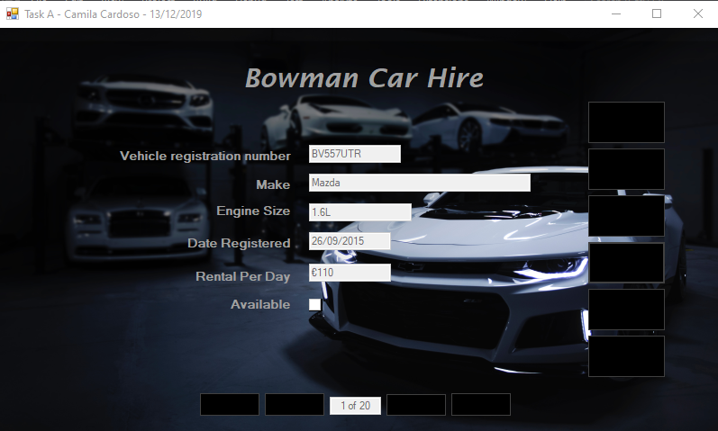TC23 – Screen FrmSearch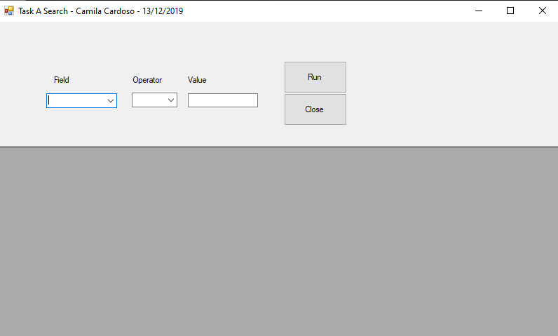TC24 – Screen FrmSearch – Field: Make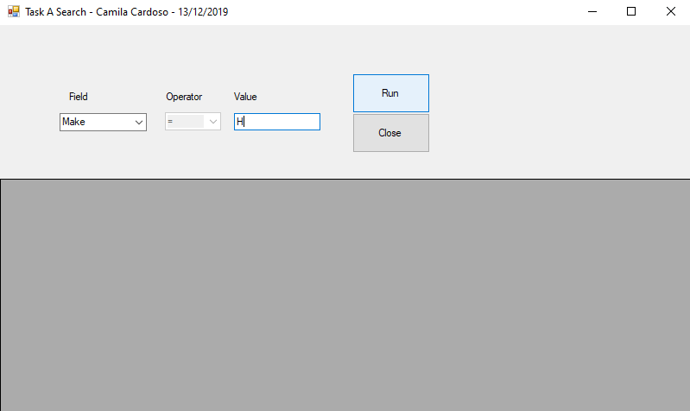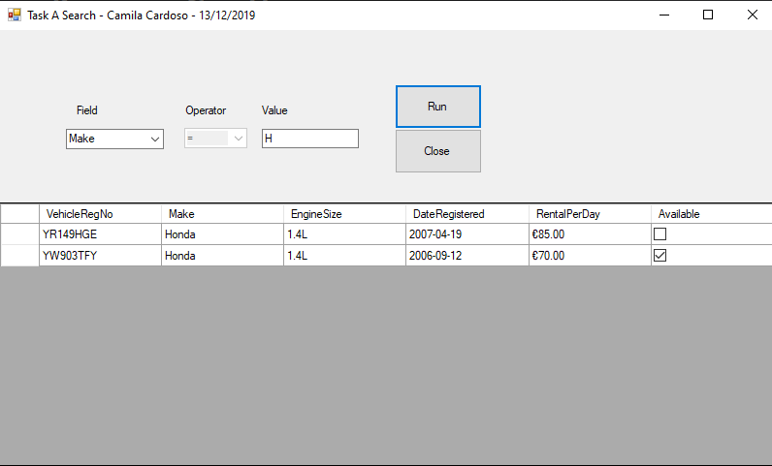TC24 – Table tblCar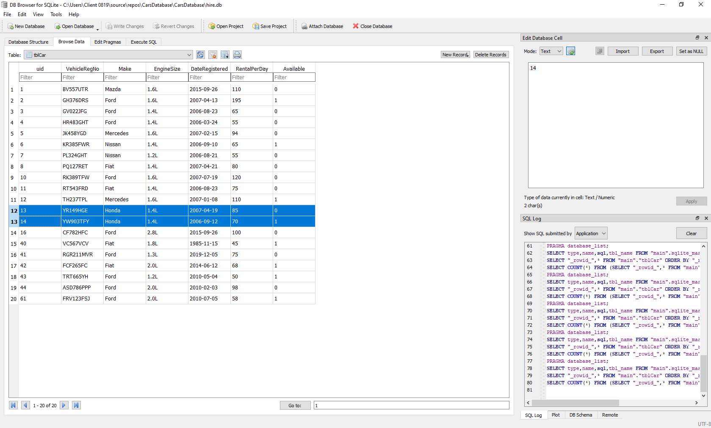TC25 – Screen FrmSearch – Field: Engine Size = 1.6L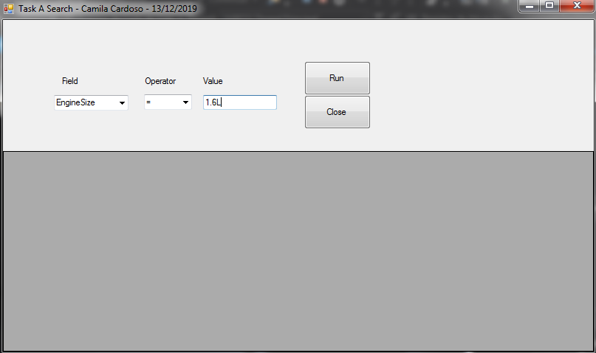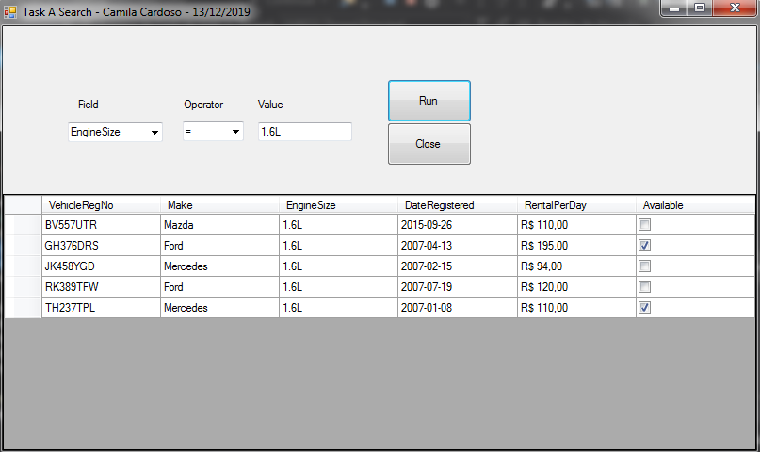TC25 – Table tblCar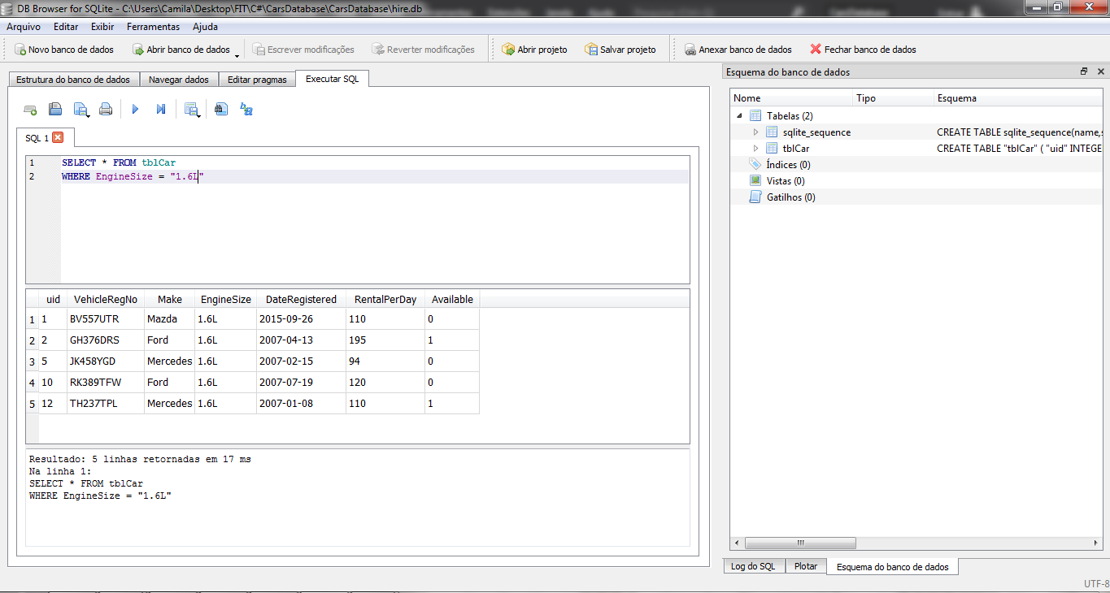TC26 – Screen FrmSearch – Field: Engine Size < 1.4L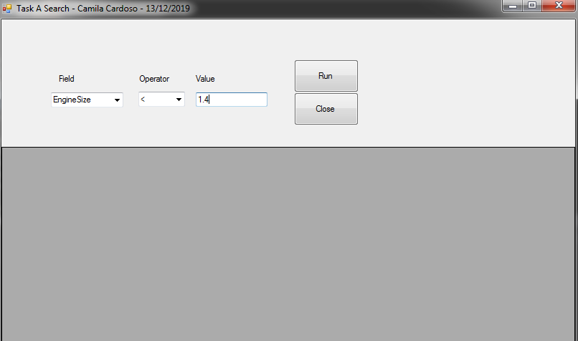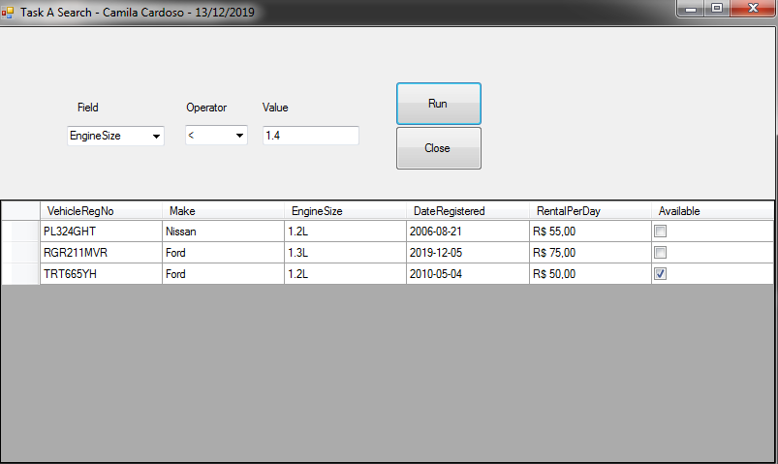TC26 – Table tblCar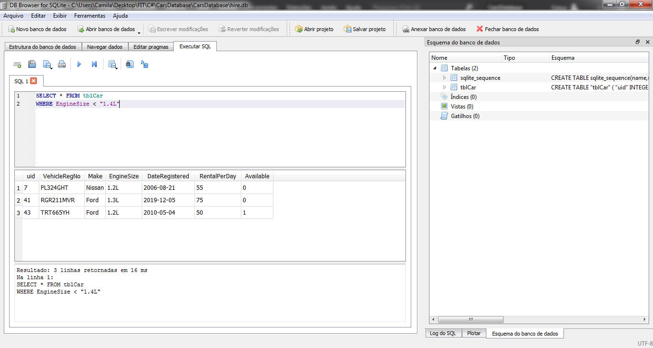TC27 – Screen FrmSearch – Field: Engine Size > 1.8L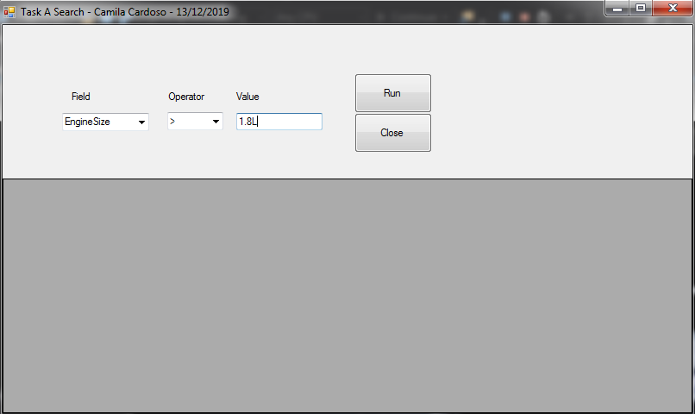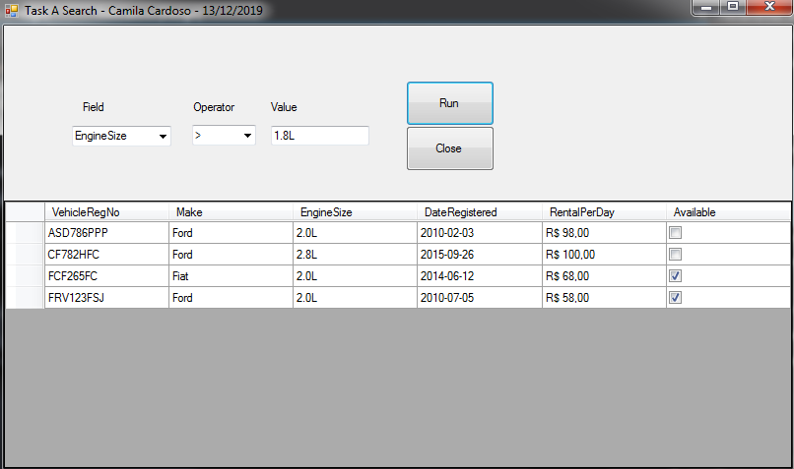TC27 – Table tblCar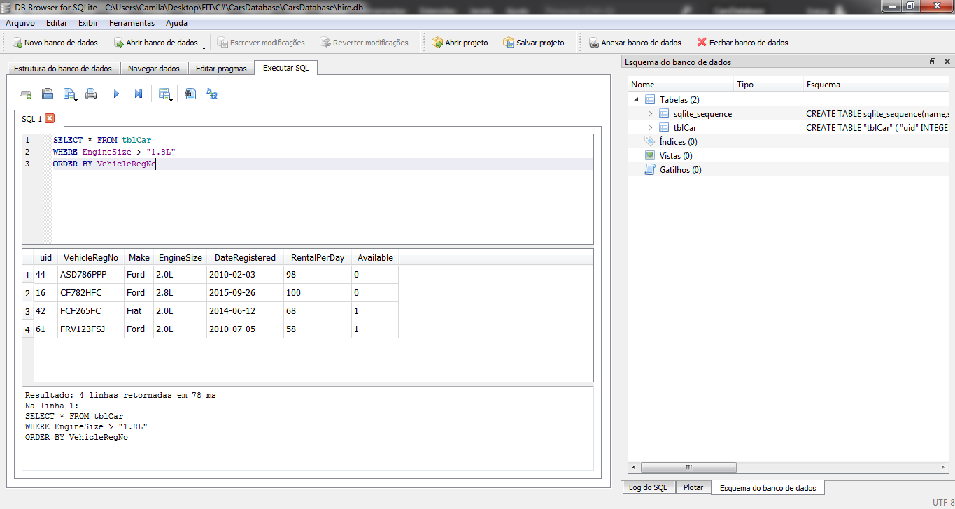TC28 – Screen FrmSearch – Field: Engine Size <= 1.3L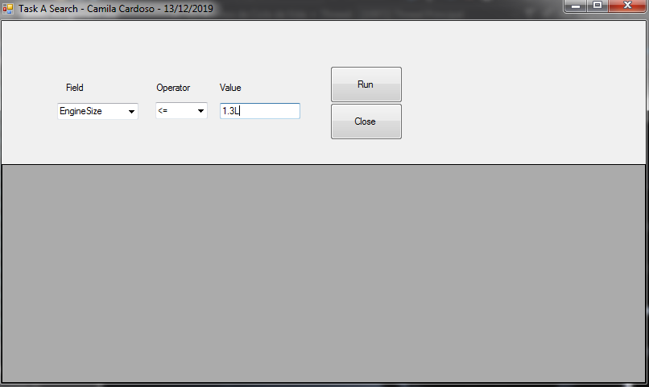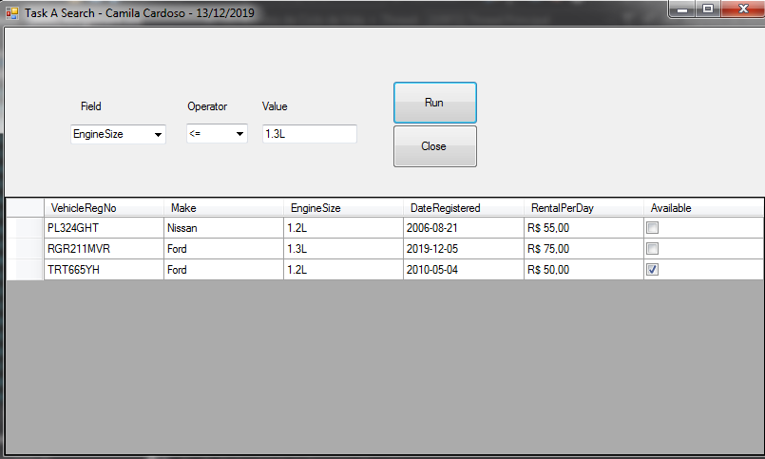TC28 – Table tblCar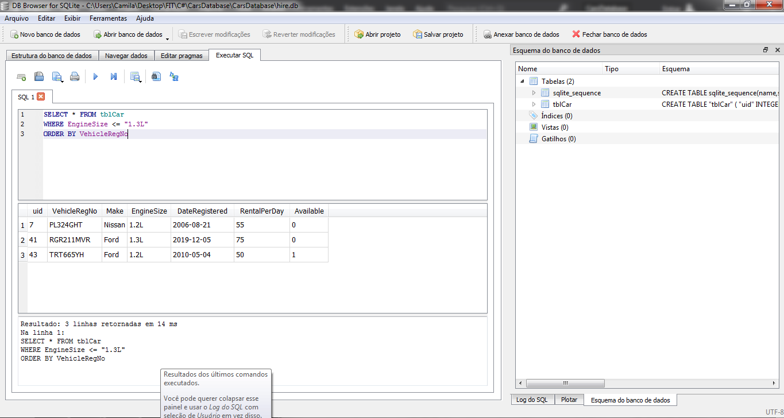TC29 – Screen FrmSearch – Field: Engine Size >= 2.0L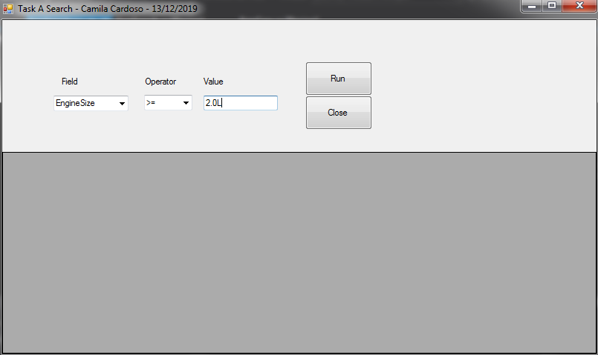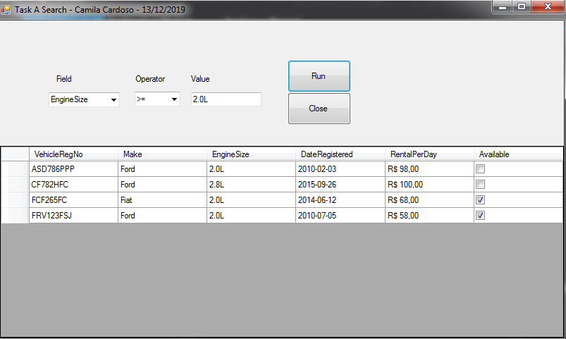TC29 – Table tblCar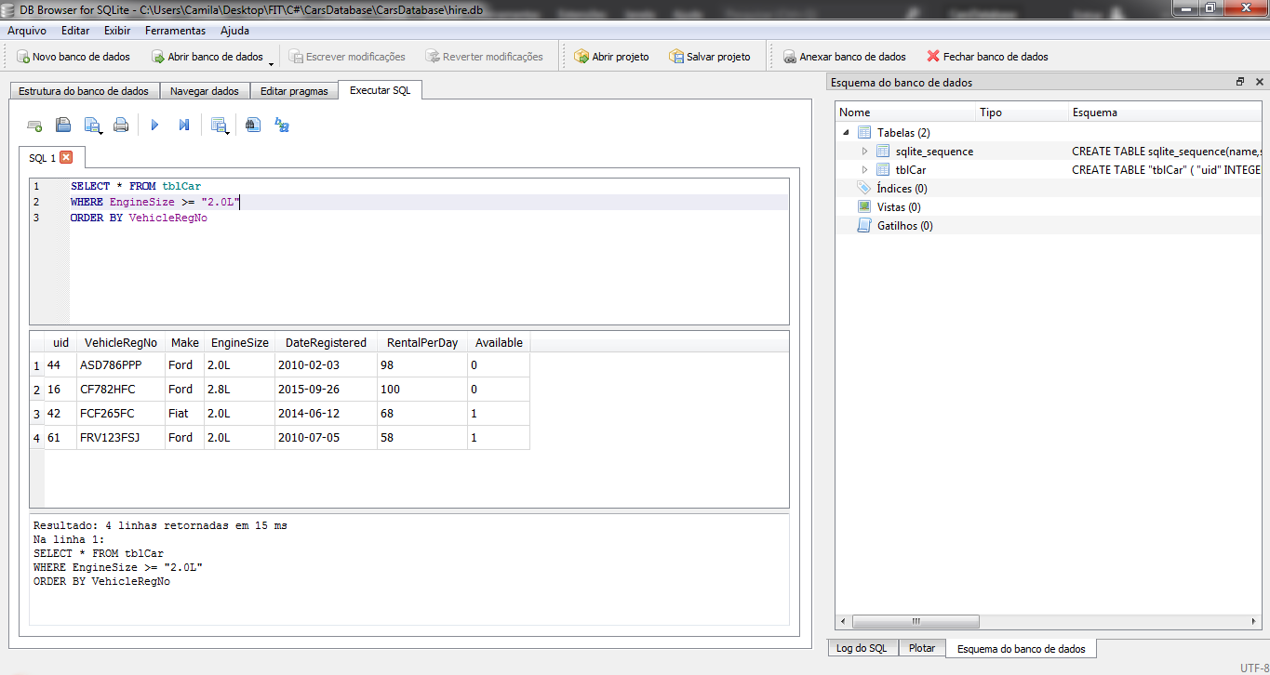TC30 – Screen FrmSearch – Field: Rental Per Day = 50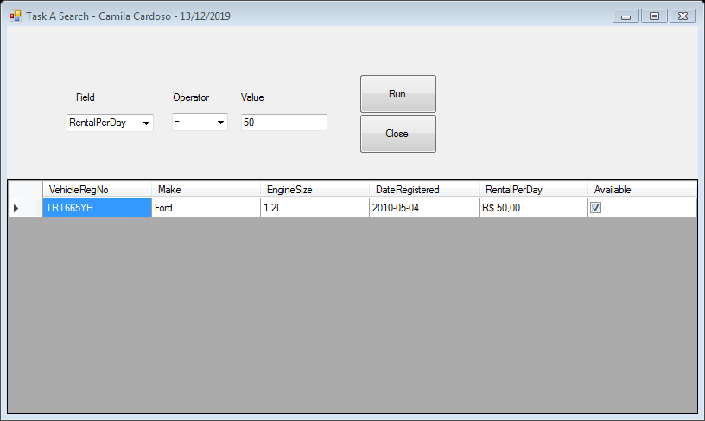TC30 – Table tblCar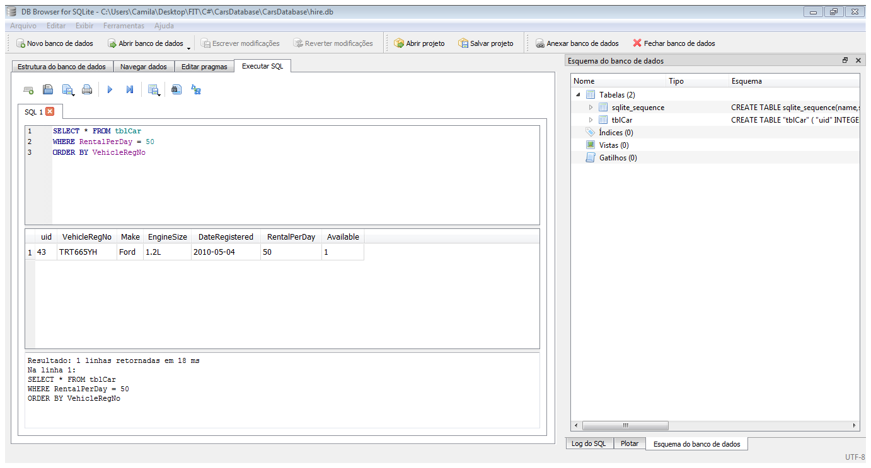TC31 – Screen FrmSearch – Field: Rental Per Day < 60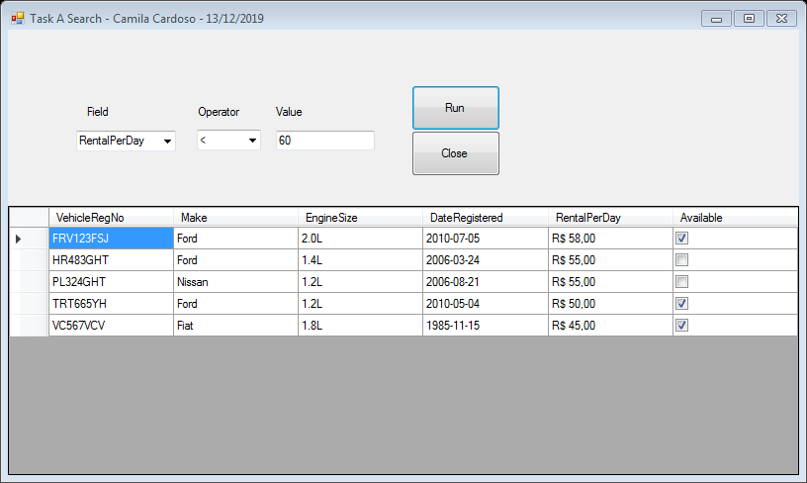TC31 – Table tblCar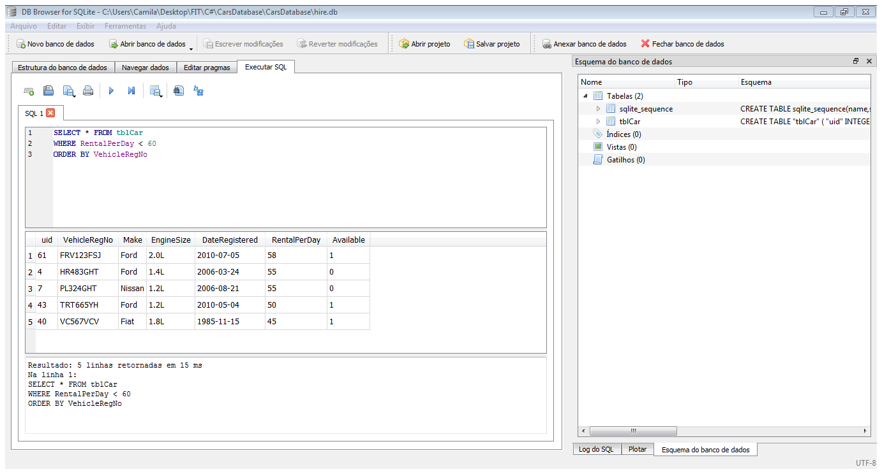TC32 – Screen FrmSearch – Field: Rental Per Day > 100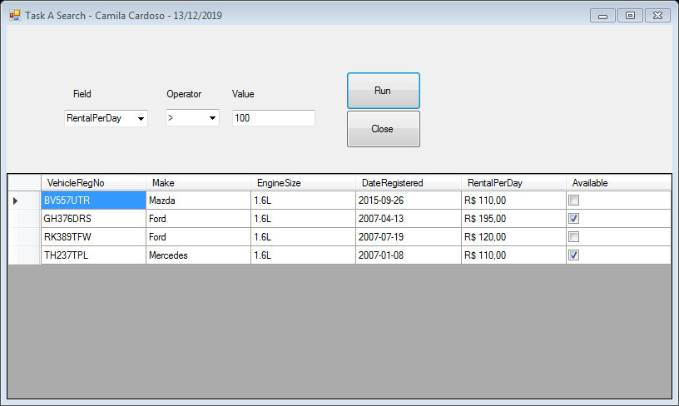TC32 – Table tblCar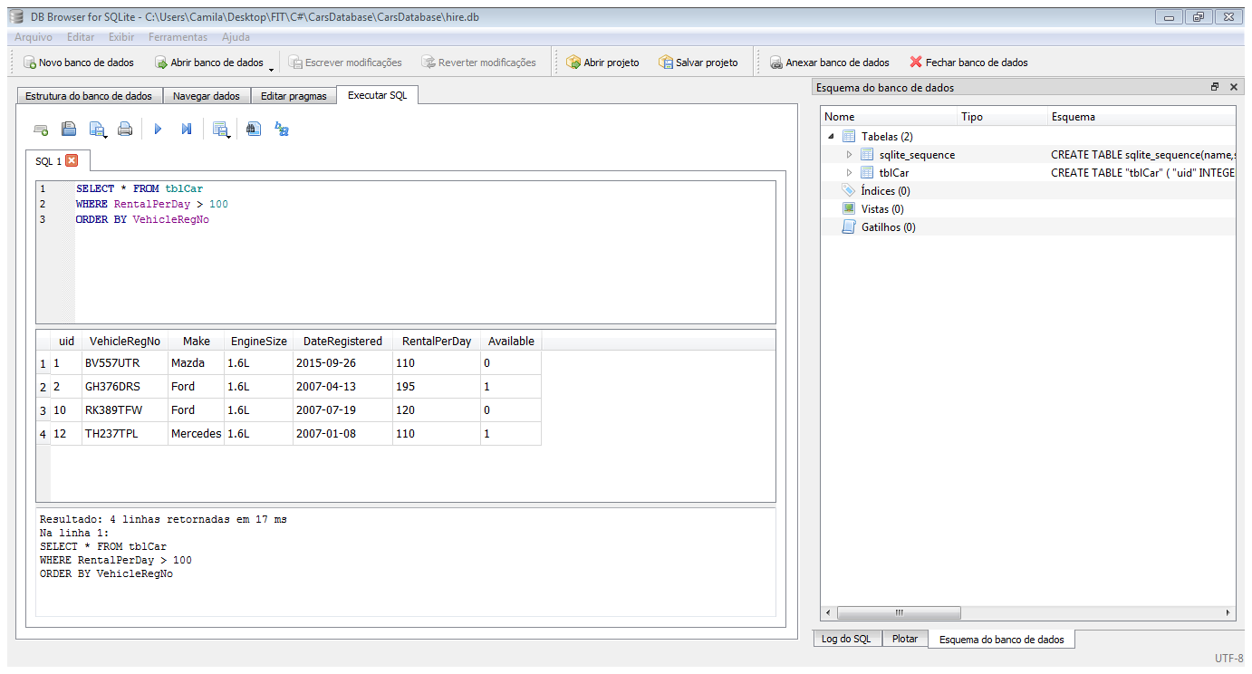TC33 – Screen FrmSearch – Field: Rental Per Day <= 55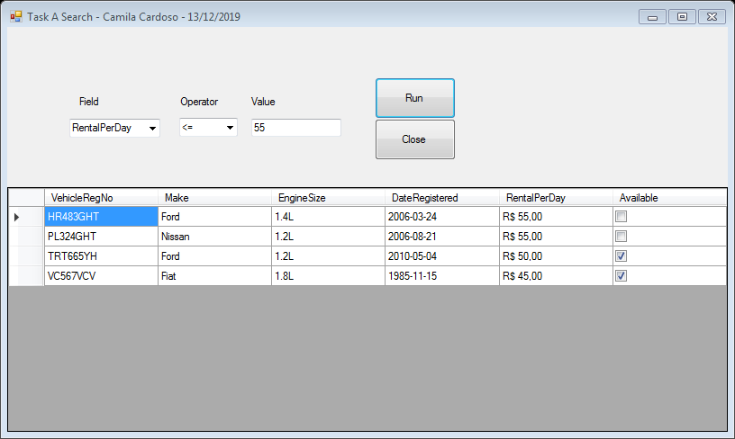TC33 – Table tblCar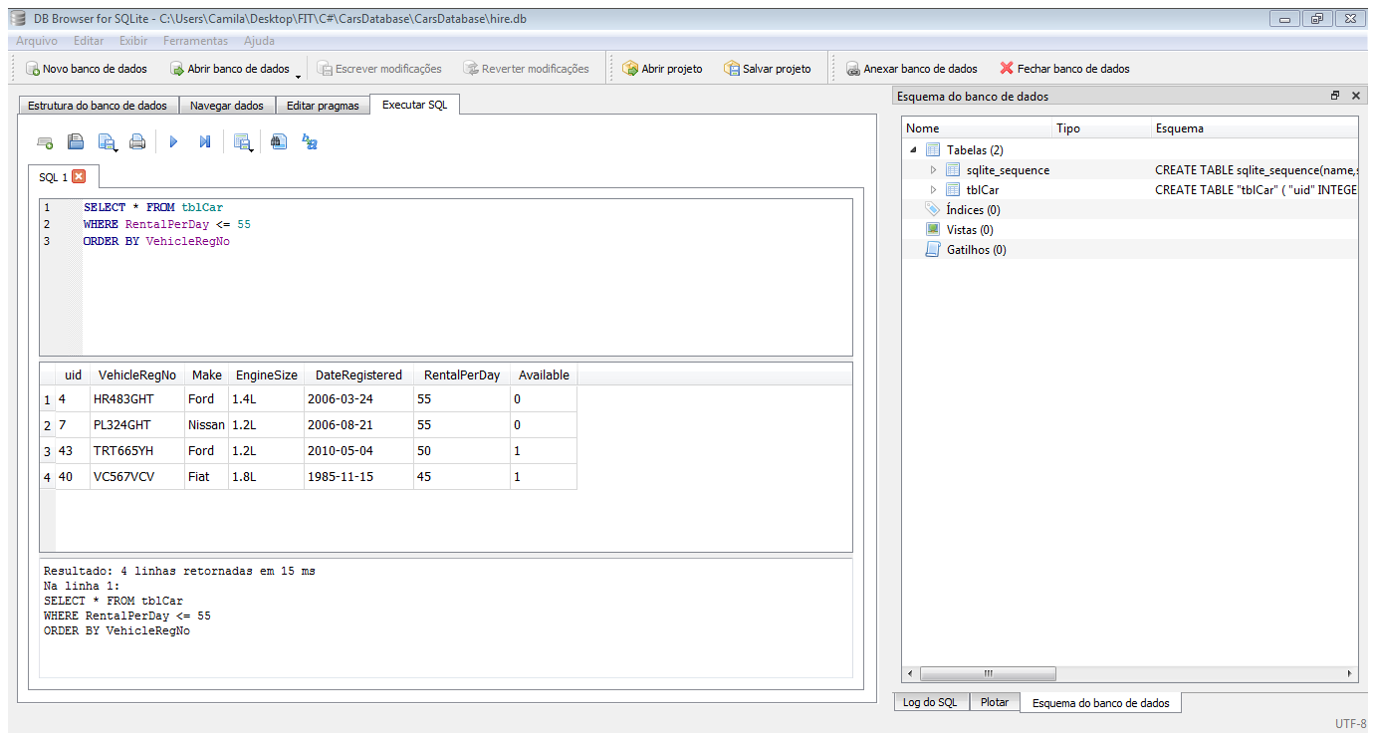TC34 – Screen FrmSearch – Field: Rental Per Day >= 120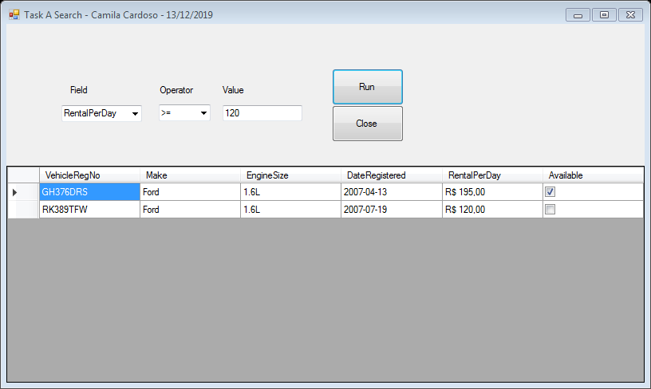TC34 – Table tblCar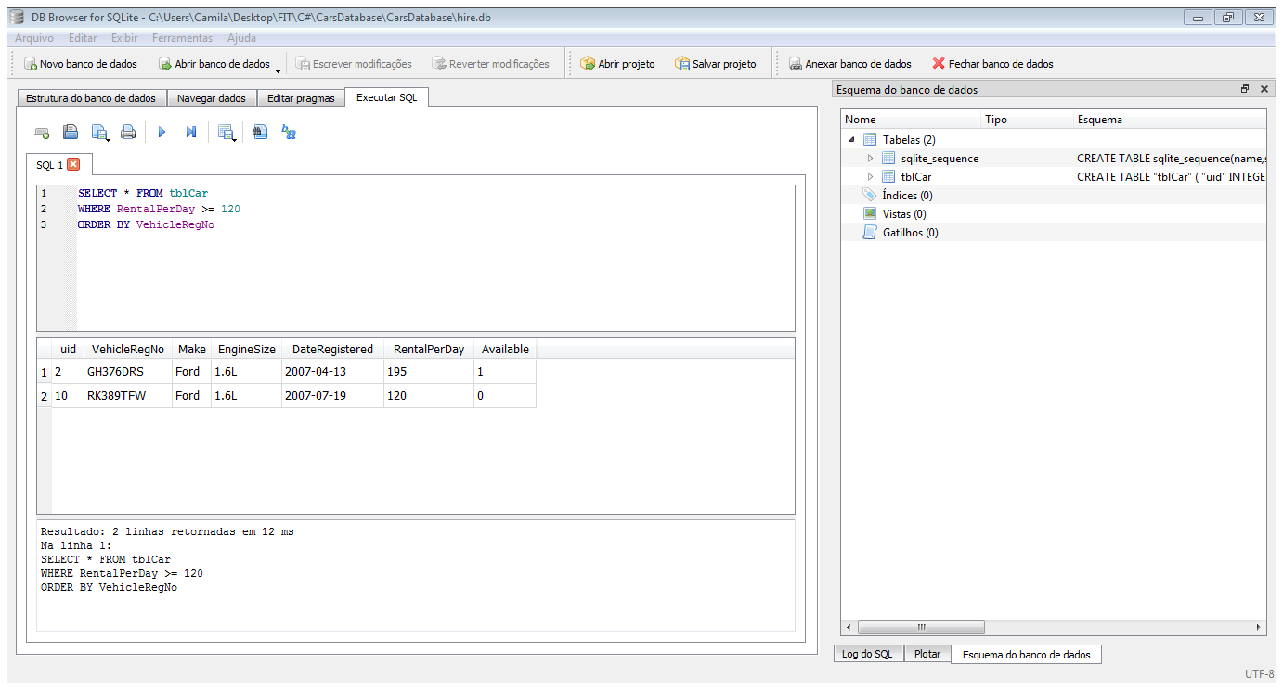TC35 – Screen FrmSearch – Field: Available = Yes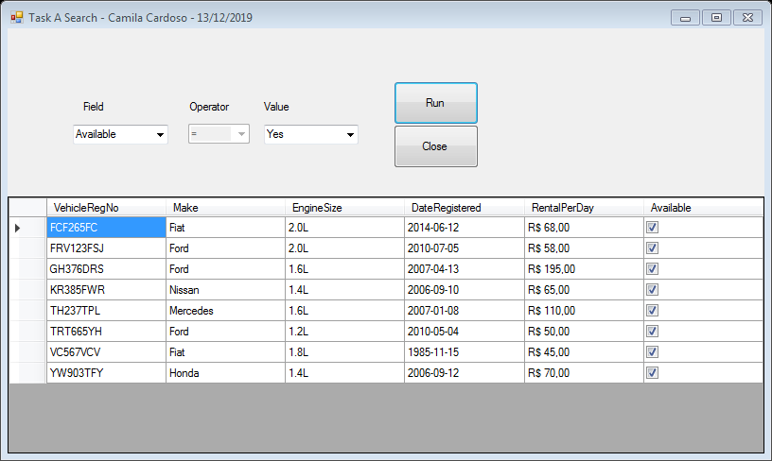TC35 – Table tblCar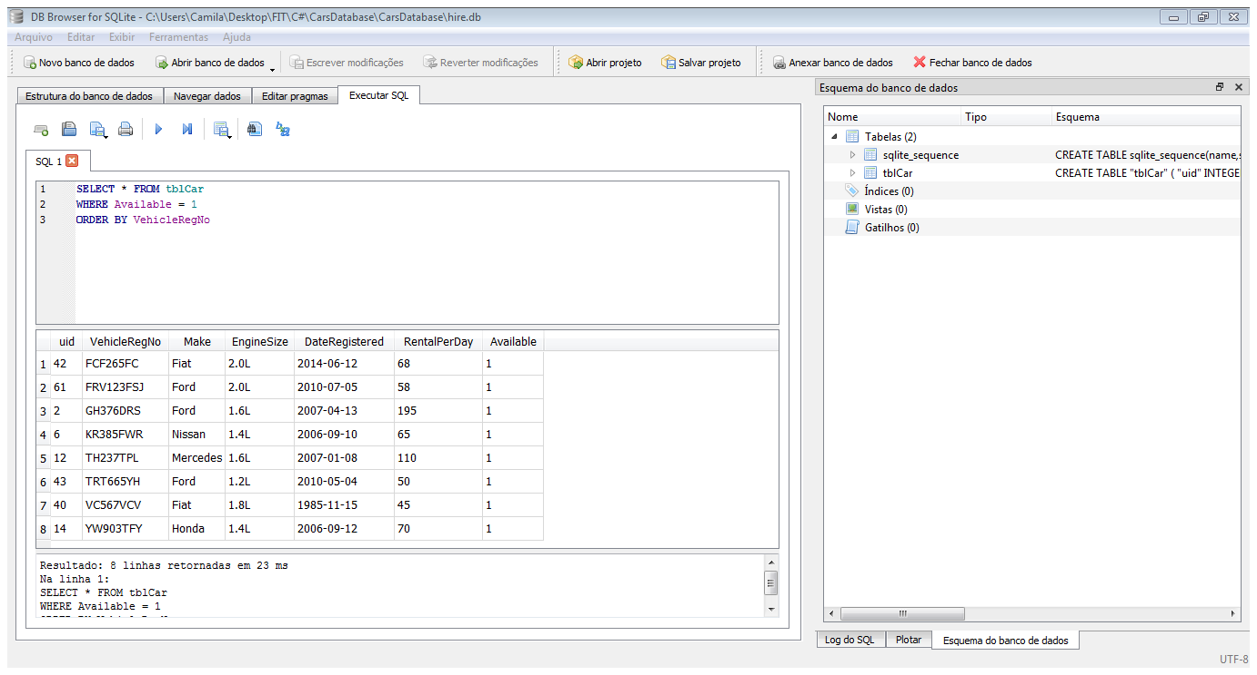TC36 – Screen FrmSearch – Field: Available = No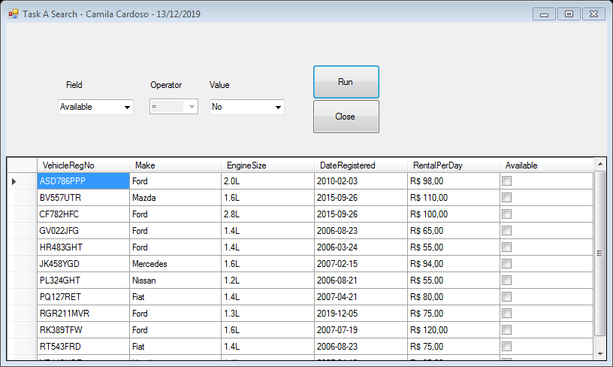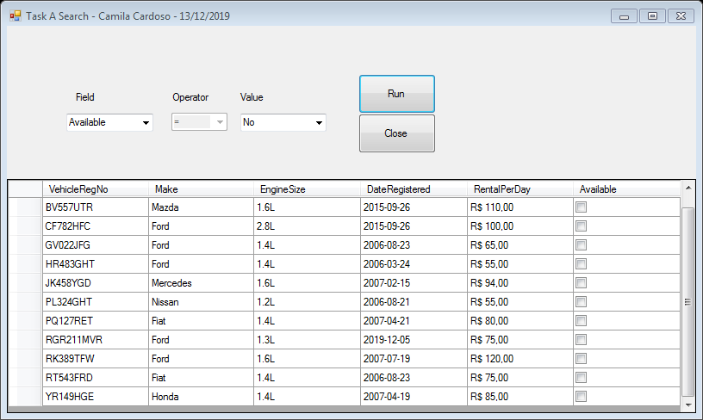TC36 – Table tblCar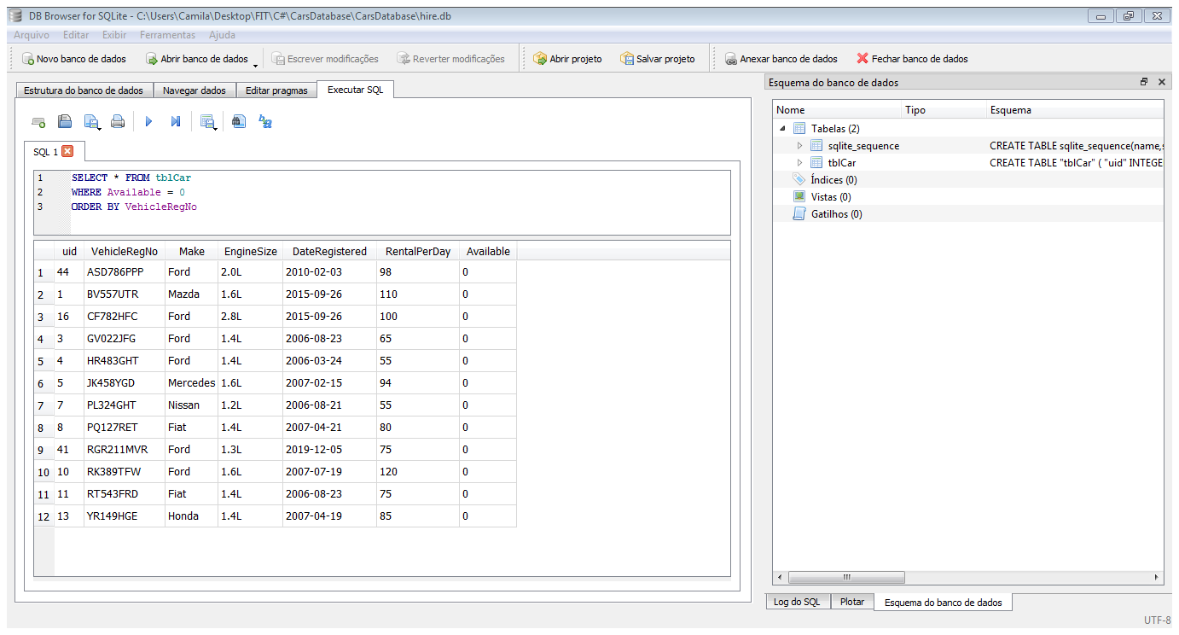TC37.1 – Screen FrmSearch – All fields blank – Returned an exception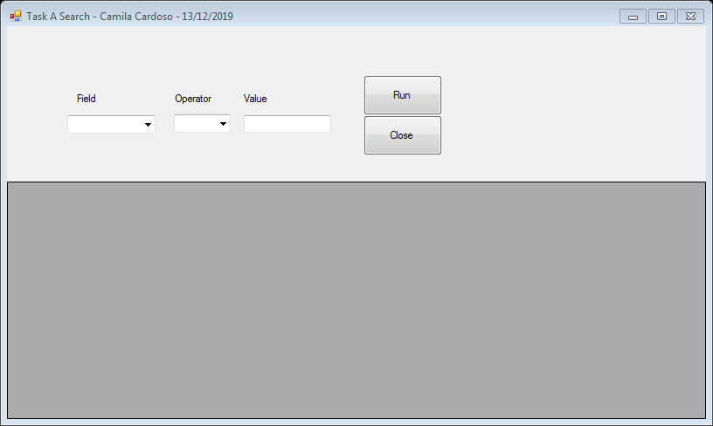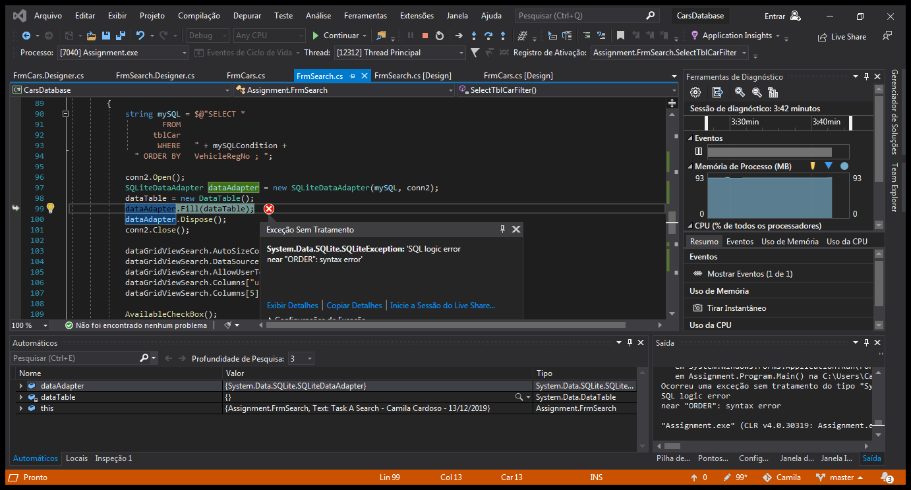TC37.2 – Screen FrmSearch – All fields blank – Returned an error message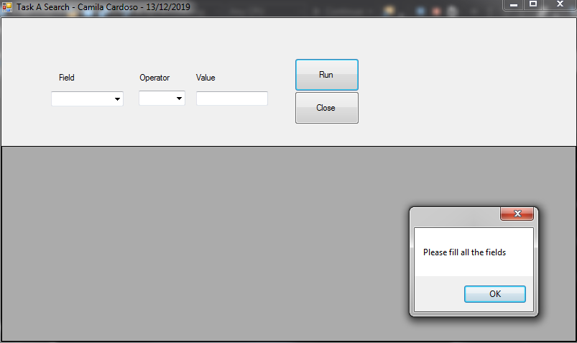TC38 – Screen FrmSearch – Close button****TC38 – Screen FrmCars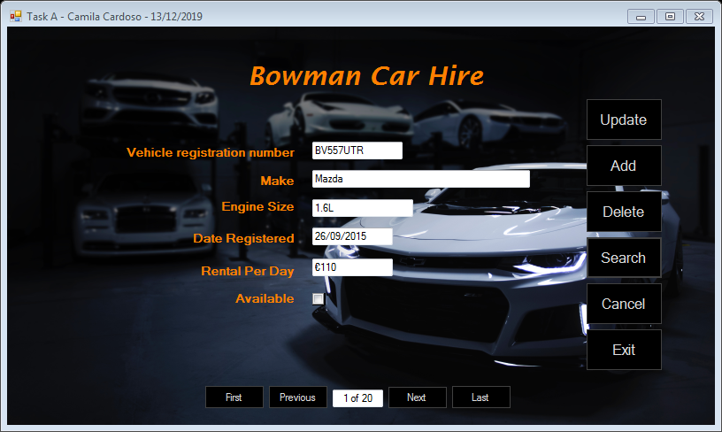TC39 – Screen FrmCars – ToolTips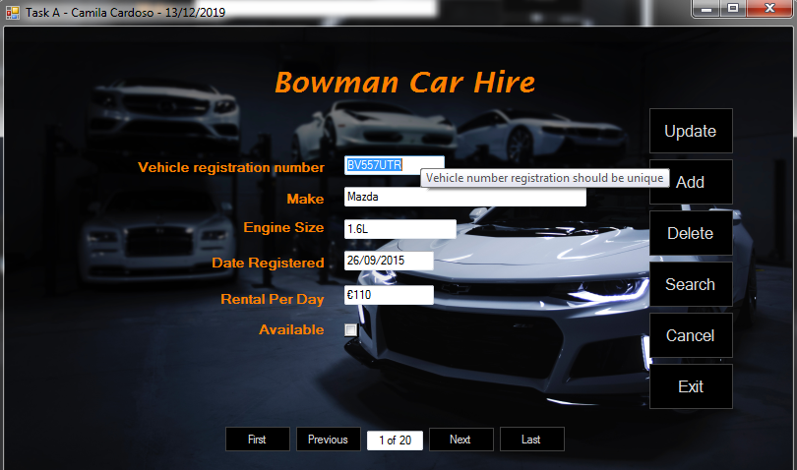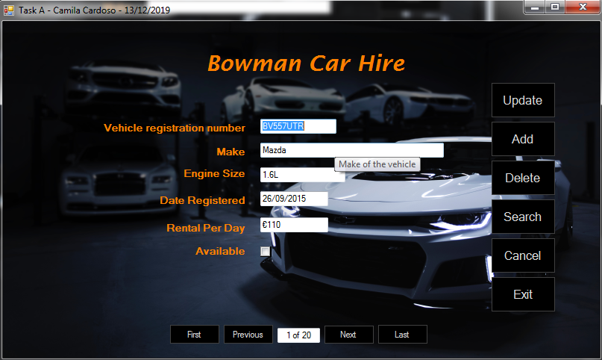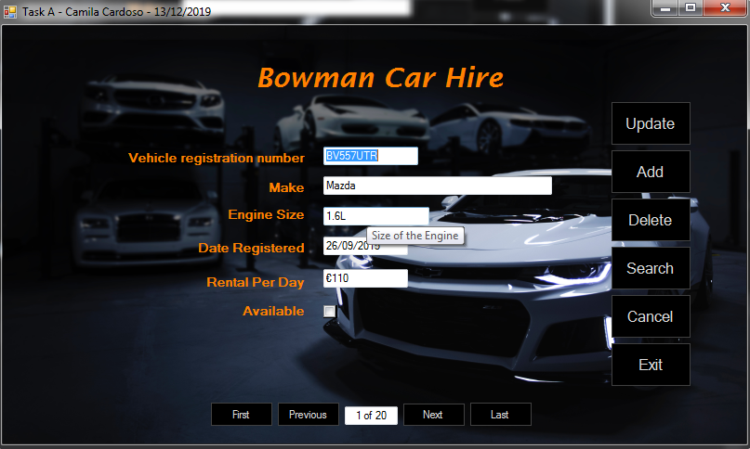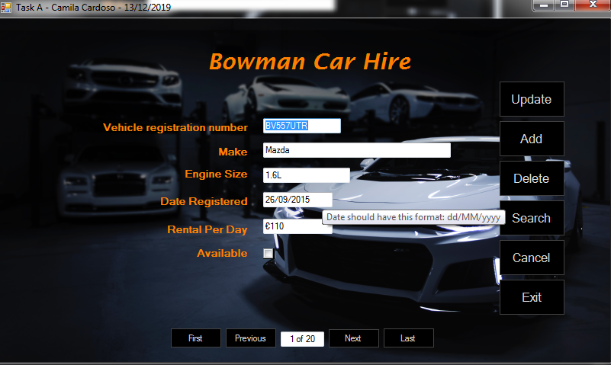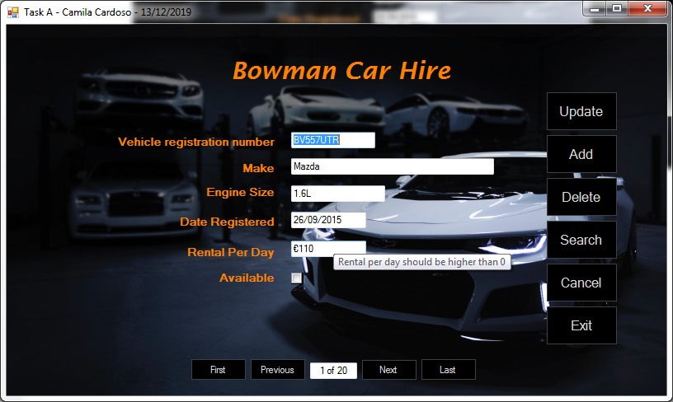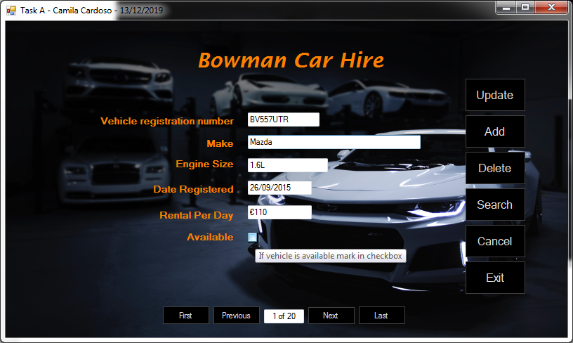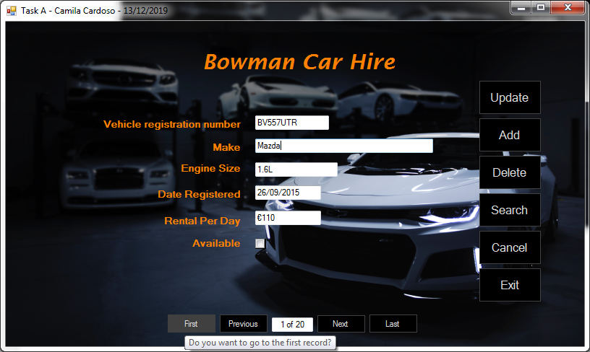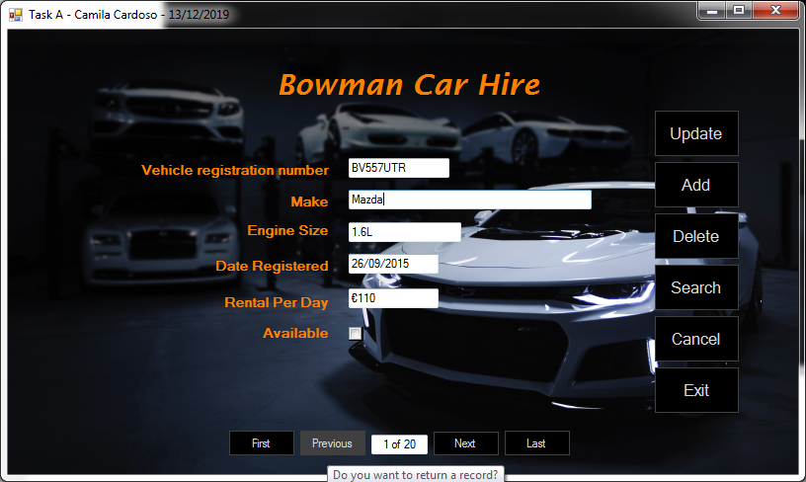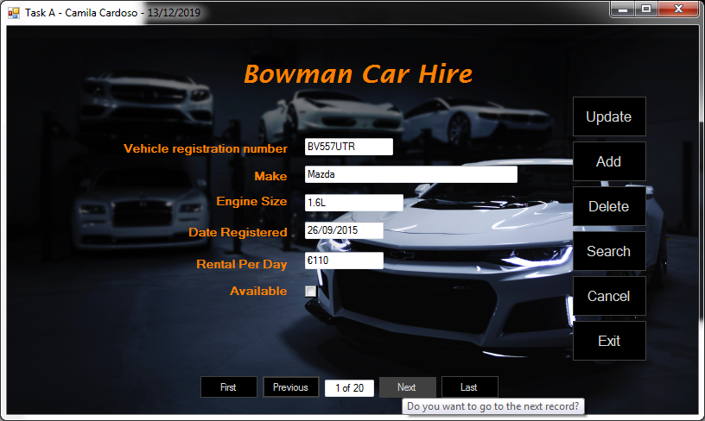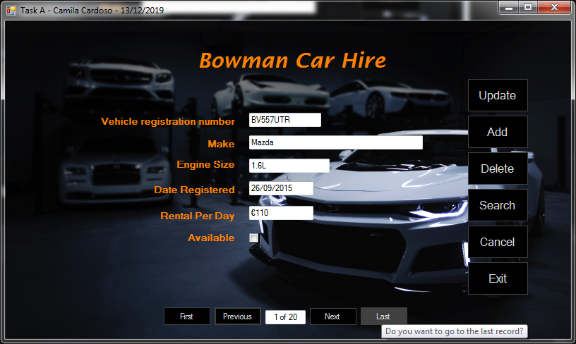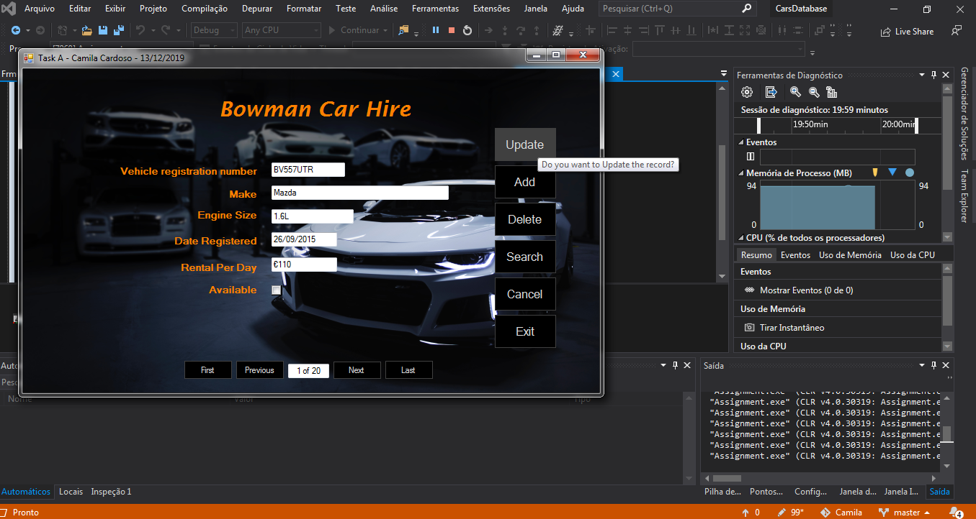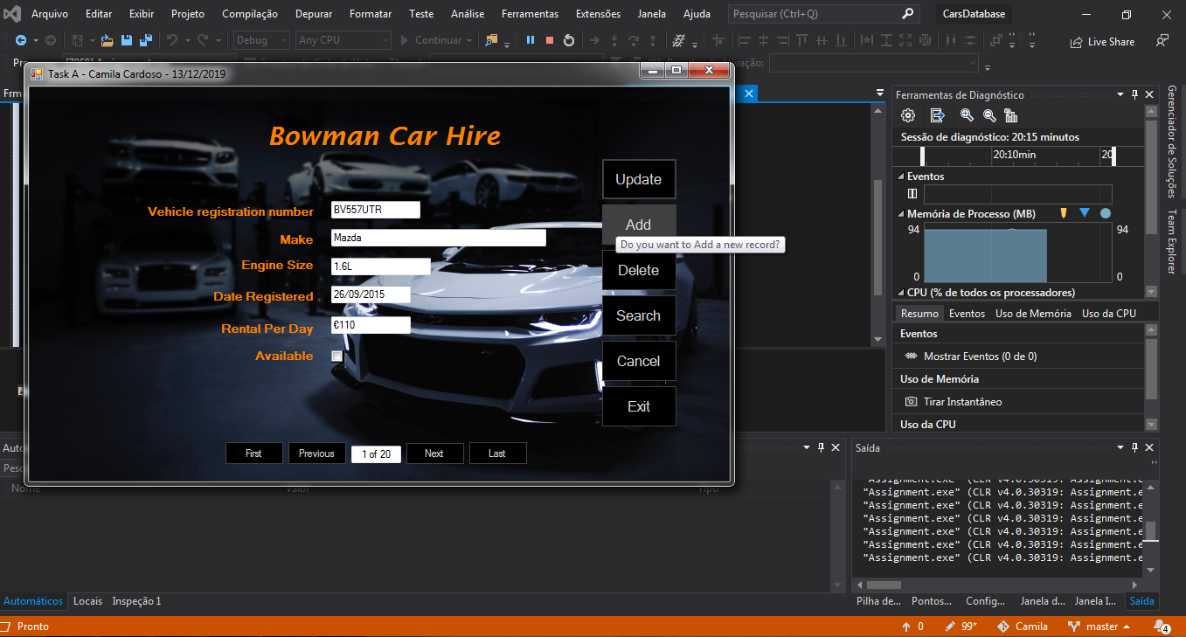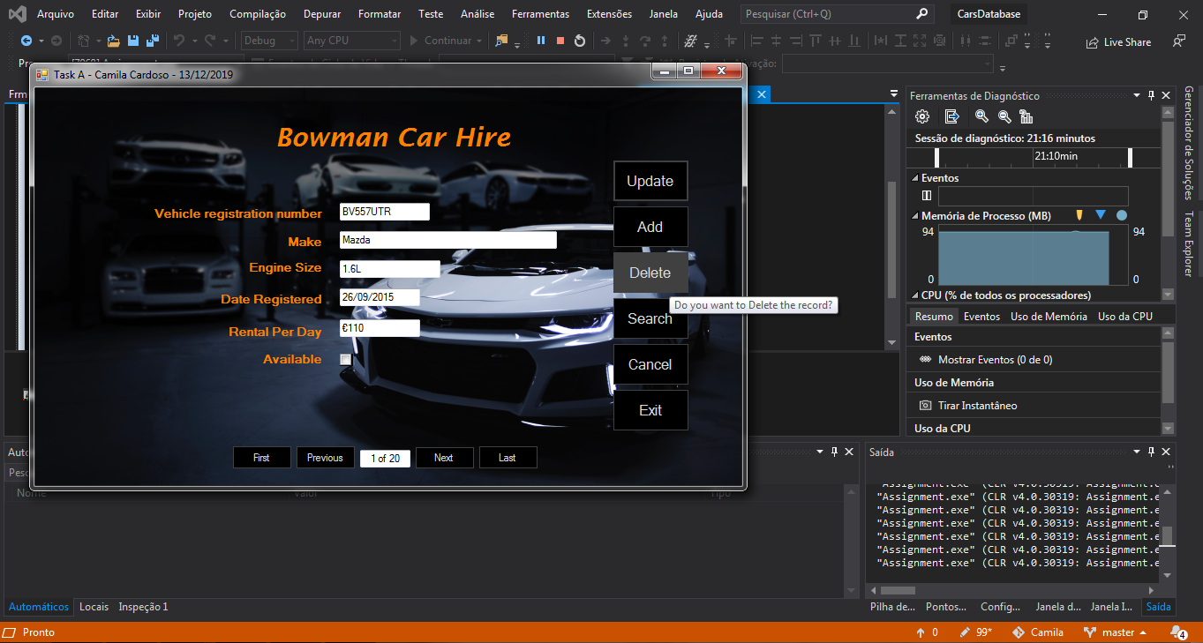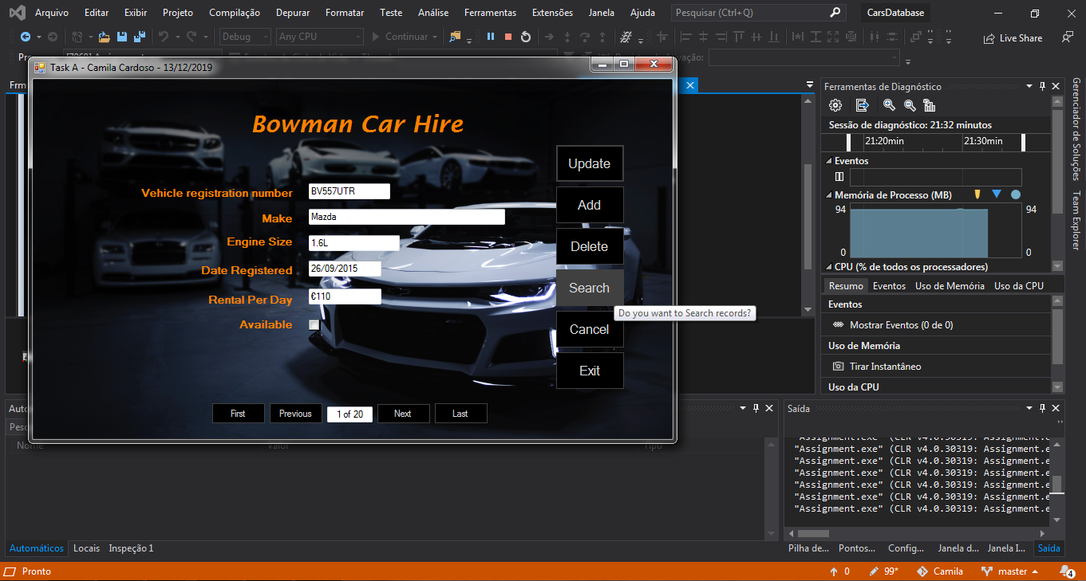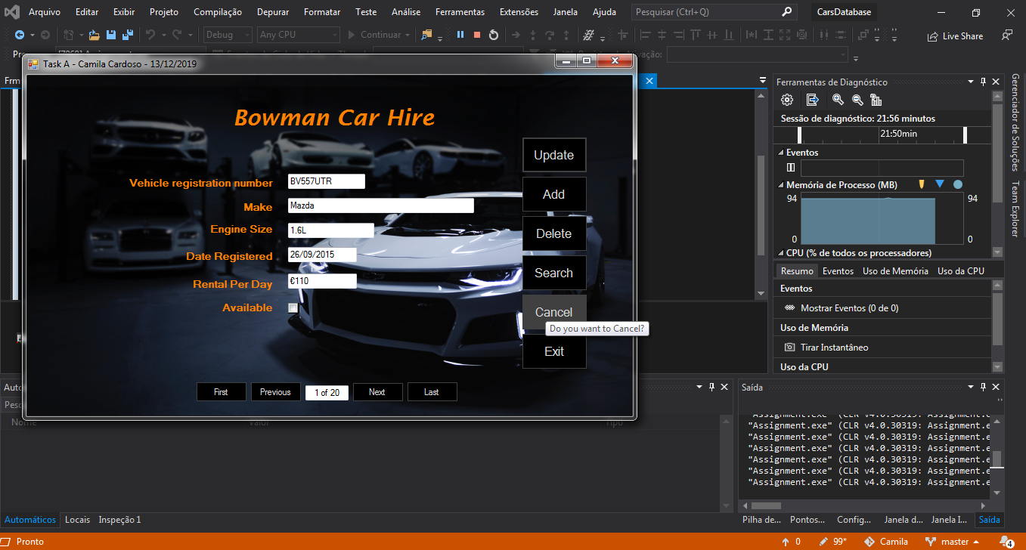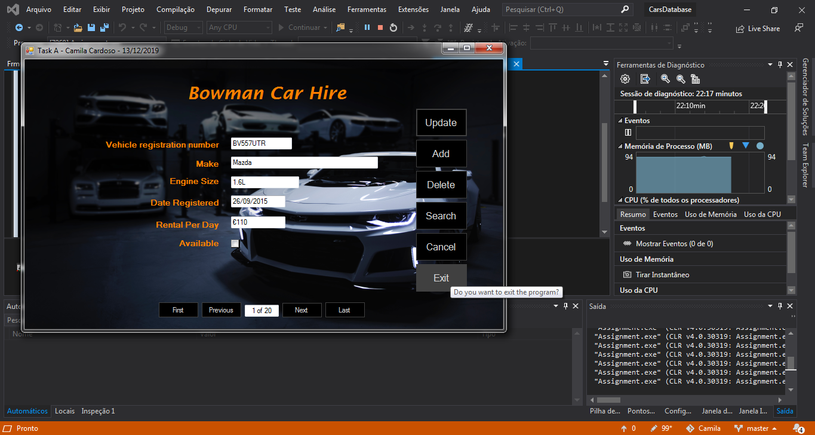

**EXE file**

